Media Kit for COVID-19 released by Department of Health & Family Welfare, Government of Nagaland

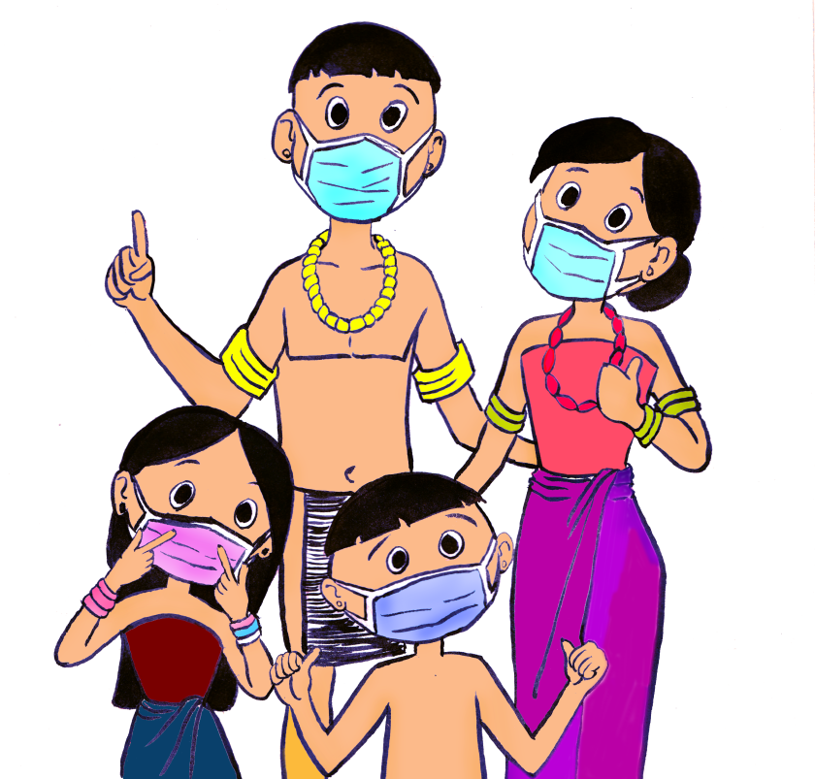

1. COVID-19
It is a disease caused by a new strain of corona virus. 'CO' stands for corona, 'VI' for virus, and 'D' for disease. This disease was referred to as '2019 novel corona virus' or '2019-nCoV.'COVID-19 is caused by infection with the severe acute respiratory syndrome corona virus 2 (SARS-CoV-2) virus strains.

2. What is corona virus?
Corona viruses are a large family of viruses which may cause illness in animals or humans. In humans, several corona viruses are known to cause respiratory infections ranging from the common cold to more severe diseases such as Middle East Respiratory Syndrome (MERS) and Severe Acute Respiratory Syndrome (SARS). The most recently discovered corona virus causes corona virus disease COVID-19.
April 2021 has marked a series of harsh COVID milestone for India. The country once again outstripped Brazil to become the second-worst affected globally with a total of over 13.68 Million cases. On 12th April, India reported nearly 1.69 lakh cases and 904 deaths in the last 24 hours, the highest-ever single-day Covid spike in the country.
The daily rise in new corona virus infections in India remained above 90,000 for the third consecutive day taking the nationwide COVID-19 tally of cases to 1,26,86,049.
In Nagaland, the total positive cases reported stands at 12440 and counting as on 15th April 2021 with 83+ active cases presently. The spike of positive cases has been seen in our State since April that may likely mark the onset of 2nd Wave. (Visit www.covid19.nagaland.gov.in for more daily updates).
A new COVID strain and some newer symptoms are found in patients like fever, pain in muscles, dry and persistent cough, and loss of smell and taste. Additionally, conjunctivitis, sore throat, headache, rashes, upset stomach and discolouration of fingers and toes are some of the new symptoms of the new strain

COVID-19 tally in India crossed:
- 60 lakh mark on September 28, 2020
- 70 lakh mark on October 11, 2020
- 80 lakh mark on October 29, 2020
- 90 lakh mark on November 20, 2020
- 1 crore mark on December 19, 2020

3. What can I do to protect myself and prevent the spread of disease?
You can reduce your chances of being infected or spreading COVID19 by taking some simple precautions:
- Regularly and thoroughly clean your hands with an alcohol based hand rub or wash them with soap and water. Why? Washing your hands with soap and water or using alcohol-based hand rub kills viruses that may be on your hands.
- Maintain at least 1 metre (3 feet) distance between yourself and anyone who is coughing or sneezing. Why? When someone coughs or sneezes they spray small liquid droplets from their nose or mouth which may contain virus. If you are too close, you can breathe in the droplets, including the COVID-19 virus if the person coughing has the disease.
- Avoid touching eyes, nose and mouth. Why? Hands touch many surfaces and can pick up viruses. Once contaminated, hands can transfer the virus to your eyes, nose or mouth. From there, the virus can enter your body and can make you sick.
- Make sure you, and the people around you, follow good respiratory hygiene. This means covering your mouth and nose with your bent elbow or tissue when you cough or sneeze. Then dispose of the used tissue immediately. Why? Droplets spread virus. By following good respiratory hygiene you protect the people around you from viruses such as cold, flu and COVID-19.
- Stay home if you feel unwell. If you have a fever, cough and difficulty breathing, seek medical attention and call in advance. Follow the directions of your local health authority. Why? National and local authorities will have the most up to date information on the situation in your area. Calling in advance will allow your health care provider to quickly direct you to the right health facility. This will also protect you and help prevent spread of viruses and other infections.
- Keep up to date on the latest COVID-19 hotspots (cities or local areas where COVID-19 is spreading widely). If possible, avoid traveling to places – especially if you are an older person or have diabetes, heart or lung disease. Why? You have a higher chance of catching COVID-19 in one of these areas.

4. HOW COVID-19 SPREAD?
Direct Contact:
- From person to person
- Droplets from coughing, sneezing, talking or singing.

Indirect Contact from environment:
- Touching eyes, nose or mouth after touching surfaces (door knob, railing, switch, etc) with the virus on it.

5. Who is at risk of developing severe illness?
While we are still learning about how COVID-2019 affects people, older persons and persons with pre-existing medical conditions (such as high blood pressure, heart disease, lung disease, cancer or diabetes) appear to develop serious illness more often than others.
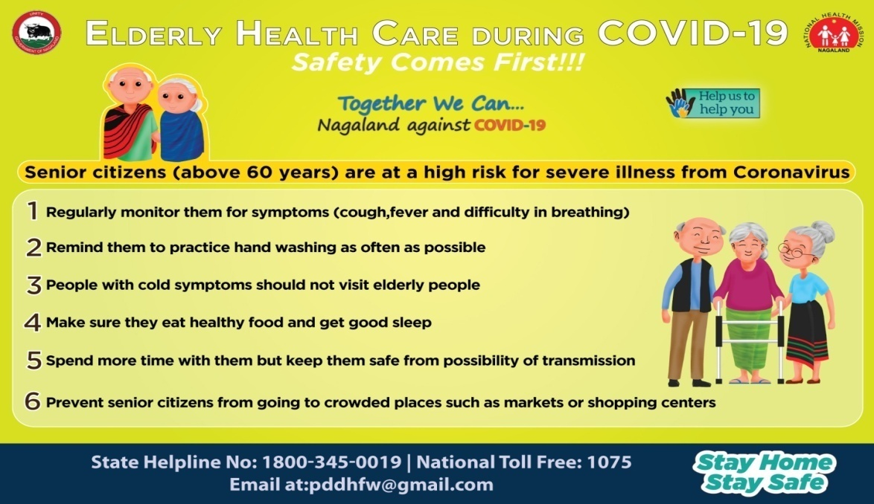

6. COVID-19 affects different people in different ways. Most infected people will develop mild to moderate illness and recover without hospitalization.
Most common symptoms:
- Fever
- Dry cough
- Tiredness
Less common symptoms:
- Aches and pains
- Sore throat
- Diarrhea
- Conjunctivitis
- Headache
- Loss of taste or smell
- A rash on skin, or discoloration of fingers or toes

7. TREATMENTS:
a. Self-care
After exposure to someone who has COVID-19, do the following:
- Call your health care provider or COVID-19 hotline to find out where and when to get a test.
- Cooperate with contact-tracing procedures to stop the spread of the virus.
- If testing is not available, stay home and away from others for 14 days.
- While you are in quarantine, do not go to work, to school or to public places. Ask someone to bring you supplies.
- Keep at least a 1-metre distance from others, even from your family members.
- Wear a medical mask to protect others, including if/when you need to seek medical care.
- Clean your hands frequently.
- Stay in a separate room from other family members, and if not possible, wear a medical mask.
- Keep the room well-ventilated.
- If you share a room, place beds at least 1 metre apart.
- Monitor yourself for any symptoms for 14 days.
- Call your health care provider immediately if you have any of these danger signs: difficulty breathing, loss of speech or mobility, confusion or chest pain.
- Stay positive by keeping in touch with loved ones by phone or online, and by exercising at home.

b. Medical treatments
Scientists around the world are working to find and develop treatments for COVID-19.
Optimal supportive care includes oxygen for severely ill patients and those who are at risk for severe disease and more advanced respiratory support such as ventilation for patients who are critically ill.
Dexamethasone is a corticosteroid that can help reduce the length of time on a ventilator and save lives of patients with severe and critical illness.
WHO does not recommend self-medication with any medicines, including antibiotics, as a prevention or cure for COVID-19.

9. VACCINE:
Vaccination is an important tool to help stop the pandemic. Covid-19 Pandemic is far from over and may continue for years. Wearing masks and social distancing help reduce your chance of being exposed to the virus or spreading it to others, but these measures are not enough. Vaccines will work with your immune system so it will be ready to fight the virus if you are exposed.

(Flyers on COVID Vaccination attached)

10. IMPORTANT SOCIAL HANDLES:

- Website: www.nagahealth.nagaland.gov.in (For all SOPS)
www.Covid19.nagaland.gov.in (Daily updates on COVID)
- Facebook: Department of Health & Family Welfare
- YouTube: dohfw_nagaland
- Twitter: @MyGovNagaland
- Instagram: @DoHFW
11. HOW TO REGISTER AT COWIN PORTAL:
You can visit https://selfregistration.cowin.gov.in/and register with your mobile number. One mobile number can register up to 4 beneficiaries. You can select date and place of vaccination and will receive the confirmed details through SMS.

12. LIST OF CONTACT NUMBER OF CMO OFFICES

- KOHIMA
- Thejawelie Gregory – Deputy Commissioner : 9863148838
- Vekhosa Chakesang – Superintendent of Police : 9856167337/8575045500
- Dr.Vizakholu – Chief Medical Officer : 9436000514/8257997279
- Dr. Kubonuo – Medical : 9436006404
- Dr. Thorise – Managing Director : 9436000649/8415954580

- DIMAPUR
- Anoop Khinchi - Deputy Commissioner : 7085055001
- R. Tetsoe - Superintendent of Police : 9828060948
- Dr. T. Pangjung Sangtam - Chief Medical Officer : 9402634787/708528513
- Dr. Keshika – Medical Superintendent : 986222413

- TUENSANG
- Kumar Ramnikant IAS - Deputy Commissioner : 8787679448
- Bharat Laxman Markad - Superintendent of Police : 9405067260
- Dr. Moatemjen - Chief Medical Officer : 8787633915
- Dr. Zathung - Medical Superintendent : 9436009434

- ZUNHEBOTO
- Peter Lichamo – Deputy Commissioner : 9612061430
- Uneil - Superintendent of Police : 8787306928
- Dr. Khehokhu Chishi - Chief Medical Officer : 9436019221
- Dr. Lanuchuba - Medical Superintendent : 9436010069/8731892683

- LONGLENG
- M.Shayung Phom - Deputy Commissioner : 8119021584
- Yanithung Ezung - Superintendent of Police : 7085933073
- Dr. Obangjungla - Chief Medical Officer : 8974468741/6009922656
- Dr. Lhouvizotuo Belho - Medical Superintendent : 9436275497/9612824963

- WOKHA
- Orenthung Lotha - Deputy Commissioner : 8837452588
- Imtitoshi - Superintendent of Police : 7585055777
- Dr. C.W.Tungoe - Chief Medical Officer : 8837452588
- Dr. Thumchobeni - Medical Superintendent : 8729874935

- MON
- Thavaseelan IAS - Deputy Commissioner : 7005766737/9862884498
- Imnalensa - Superintendent of Police : 8974169017
- Longpok Lemtur – Additional Superintendent of Police : 7085896876
- Dr. Kechonngolo Sophie - Chief Medical Officer : 9436005279
- Dr.Conne - Medical Superintendent : 9436603177

- PEREN
- Sentiwapang – Deputy Commissioner : 9436060694
- Limaakum - Additional Superintendent of Police : 9436005883
- Dr.Hatling Hangsing – Chief Medical Officer : 9862259172/8837300320
- Dr. Hoito - Medical Superintendent : 8575936060

- KIPHIRE
- Sarita Yadav - Deputy Commissioner : 9971369979
- Z.Tshurkusi - Superintendent of Police : 8787542557
- Dr. E.Motsuthung - Chief Medical Officer : 6909622488/9612288948
- Dr. Bendangsangla - Medical Superintendent : 9436005235

- PHEK
- Sachin Jaiswal - Deputy Commissioner : 9717824814
- Vesupra Kezo - Superintendent of Police : 7008888945
- Dr. Vibeituonuo Mepfuo - Chief Medical Officer : 9436078701
- Dr. Tiala - Medical Superintendent : 9436004981/8787733127

- MOKOKCHUNG
- Limawapang - Deputy Commissioner : 9862244460
- Vishal - Superintendent of Police : 9958885587
- Dr.R.Chubala Aier - Chief Medical Officer : 7005163819
- Dr. Madem - Medical Superintendent : 9436006230
Directorate Control Room : 708504710/9099607609

13. LIST OF COVID VACCINATION CENTRE (CVC):

Session Sites plan for 16th April 2021
Sl.No | District | No.of Session Sites | Name of Session Sites
1 | Dimapur | 22 | District Hospital
1 | Dimapur | 22 | Dhansaripar CHC
1 | Dimapur | 22 | Chümoukedima PHC
1 | Dimapur | 22 | UPHC Ducan
1 | Dimapur | 22 | UPHC Burma Camp
1 | Dimapur | 22 | Medziphema CHC
1 | Dimapur | 22 | Thilixu HWC
1 | Dimapur | 22 | Pimla HWC
1 | Dimapur | 22 | Bade HWC
1 | Dimapur | 22 | Shokhuvi HWC
1 | Dimapur | 22 | Samuguri HWC
1 | Dimapur | 22 | CIHSR
1 | Dimapur | 22 | Zion Hospital
1 | Dimapur | 22 | Nikos Hospital
1 | Dimapur | 22 | Faith Hospital
1 | Dimapur | 22 | Lions Health Centre
1 | Dimapur | 22 | S.D. Jain Centre
1 | Dimapur | 22 | ARTC Shokhuvi
1 | Dimapur | 22 | 5 AR Kashiram
1 | Dimapur | 22 | 41 AR Medziphema
1 | Dimapur | 22 | Niuland CHC
1 | Dimapur | 22 | Kuhuboto PHC
2 | Kohima | 20 | New Secretariat
2 | Kohima | 20 | NHAK
2 | Kohima | 20 | Seikhazou UPHC
2 | Kohima | 20 | Poterlane UPHC
2 | Kohima | 20 | Viswema CHC
2 | Kohima | 20 | Sechu Zubza PHC
2 | Kohima | 20 | Kohima PHC
2 | Kohima | 20 | Kimipfuphe PHC
2 | Kohima | 20 | Jotsoma PHC
2 | Kohima | 20 | Zhadima PHC
2 | Kohima | 20 | Botsa PHC
2 | Kohima | 20 | Kezocha PHC
2 | Kohima | 20 | Chunlikha PHC
2 | Kohima | 20 | Touphema PHC
2 | Kohima | 20 | Mezoma PHC
2 | Kohima | 20 | Ziezou PHC
2 | Kohima | 20 | Jakhama PHC
2 | Kohima | 20 | Thesophenyu PHC
2 | Kohima | 20 | HQ IGAR
2 | Kohima | 20 | Khonoma PHC
3 | Kiphire | 2 | District Hospital
3 | Kiphire | 2 | Pungro CHC
4 | Longleng | 4 | District Hospital
4 | Longleng | 4 | Yongyah PHC
4 | Longleng | 4 | Yachem PHC
4 | Longleng | 4 | Tamlu PHC
5 | Mokokchung | 0 | Nil
6 | Mon | 7 | District Hospital
6 | Mon | 7 | Tizit PHC
6 | Mon | 7 | Chen PHC
6 | Mon | 7 | Wakching PHC
6 | Mon | 7 | Tobu CHC
6 | Mon | 7 | Phomching PHC
6 | Mon | 7 | Wanching PHC
7 | Phek | 9 | Chozuba Village SC
7 | Phek | 9 | District Hospital
7 | Phek | 9 | Old Phek Village SC
7 | Phek | 9 | Sutsu PHC
7 | Phek | 9 | Hutsu PHC
7 | Phek | 9 | Akhegwo PHC
7 | Phek | 9 | Lozaphuhu PHC
7 | Phek | 9 | Lekromi SC
7 | Phek | 9 | Chetheba PHC
8 | Peren | 0 | Nil
9 | Tuensang | 4 | District Hospital
9 | Tuensang | 4 | UPHC
9 | Tuensang | 4 | Shamator CHC
9 | Tuensang | 4 | Panso PHC
10 | Wokha | 4 | District Hospital
10 | Wokha | 4 | Chukitong PHC
10 | Wokha | 4 | Wokha Village HWC
10 | Wokha | 4 | UPHC
11 | Zunheboto | 1 | District Hospital
Total |  | 73

14. COVID APPROPRIATE BEHAVIOUR:
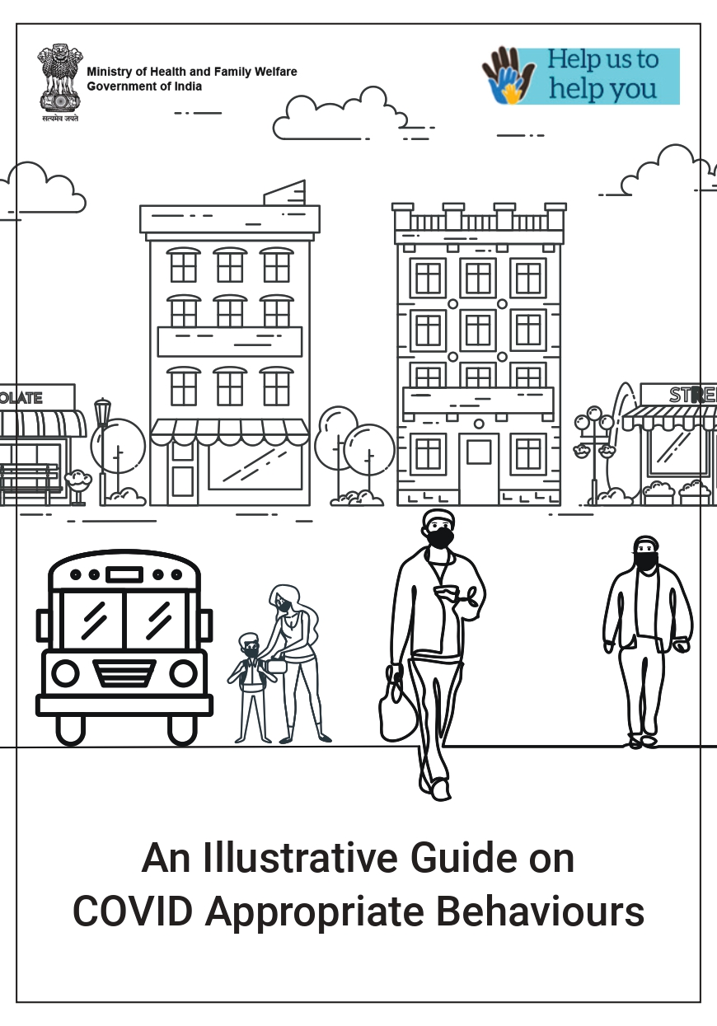

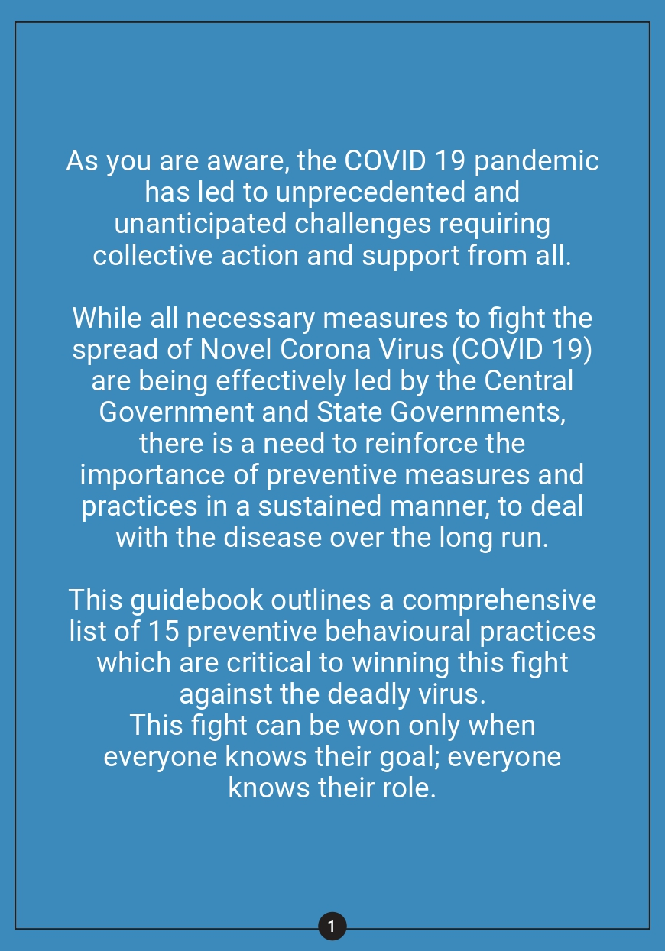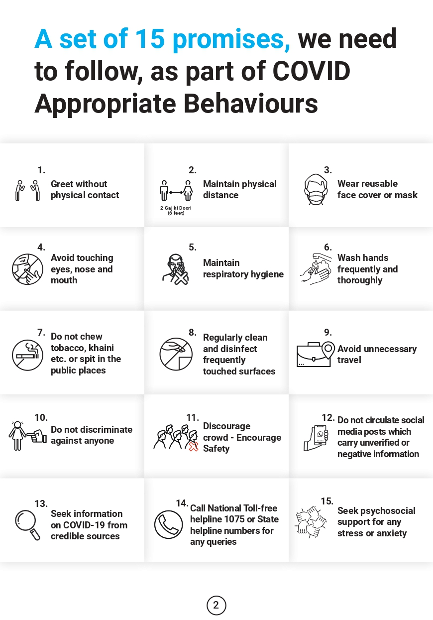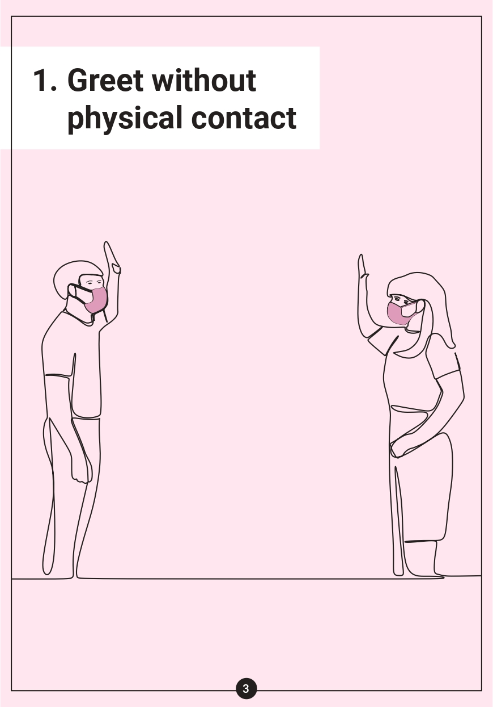

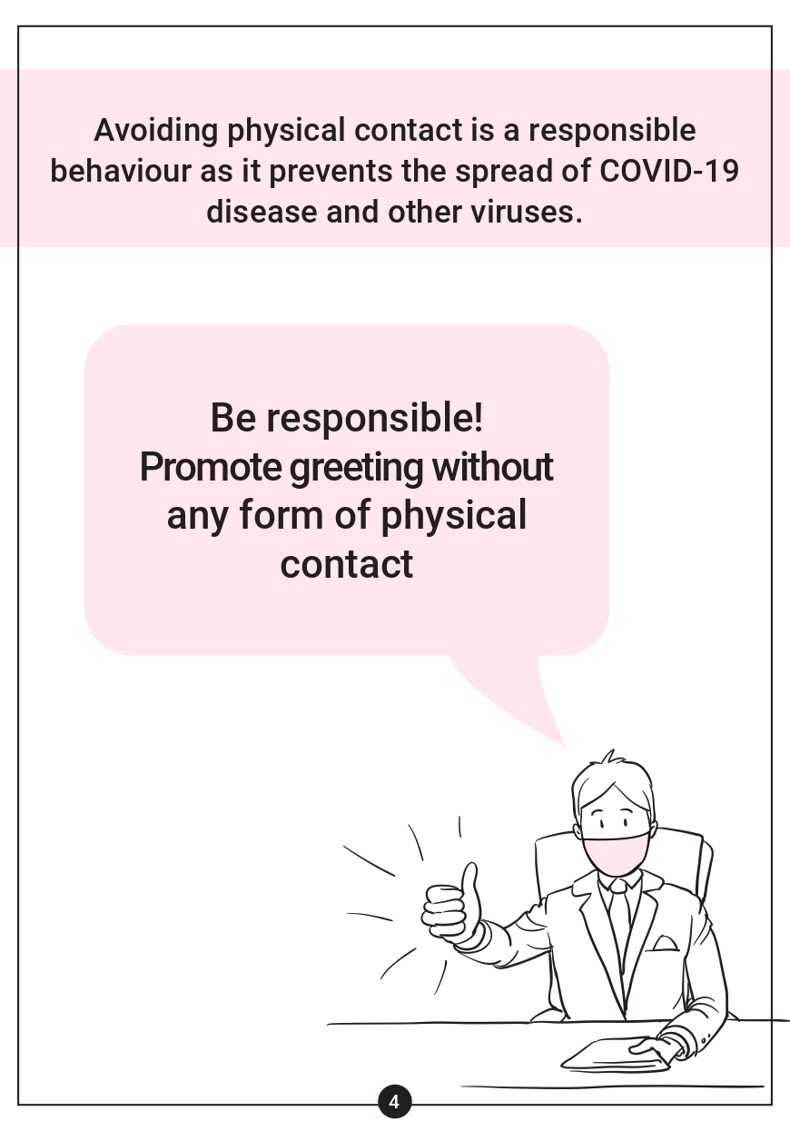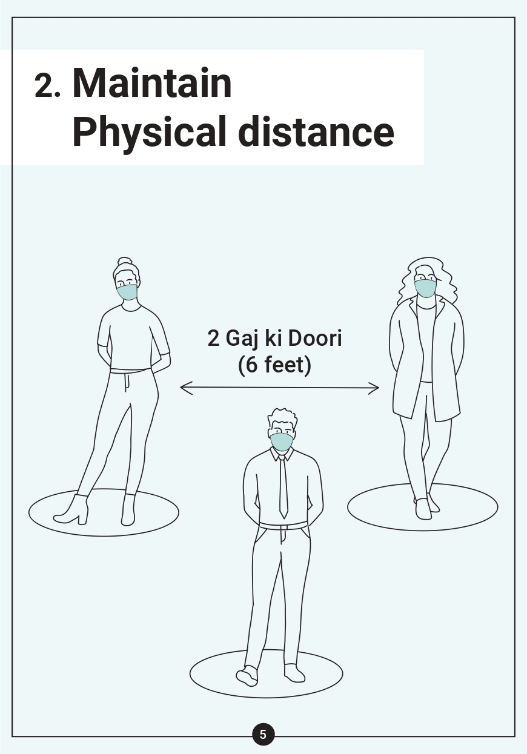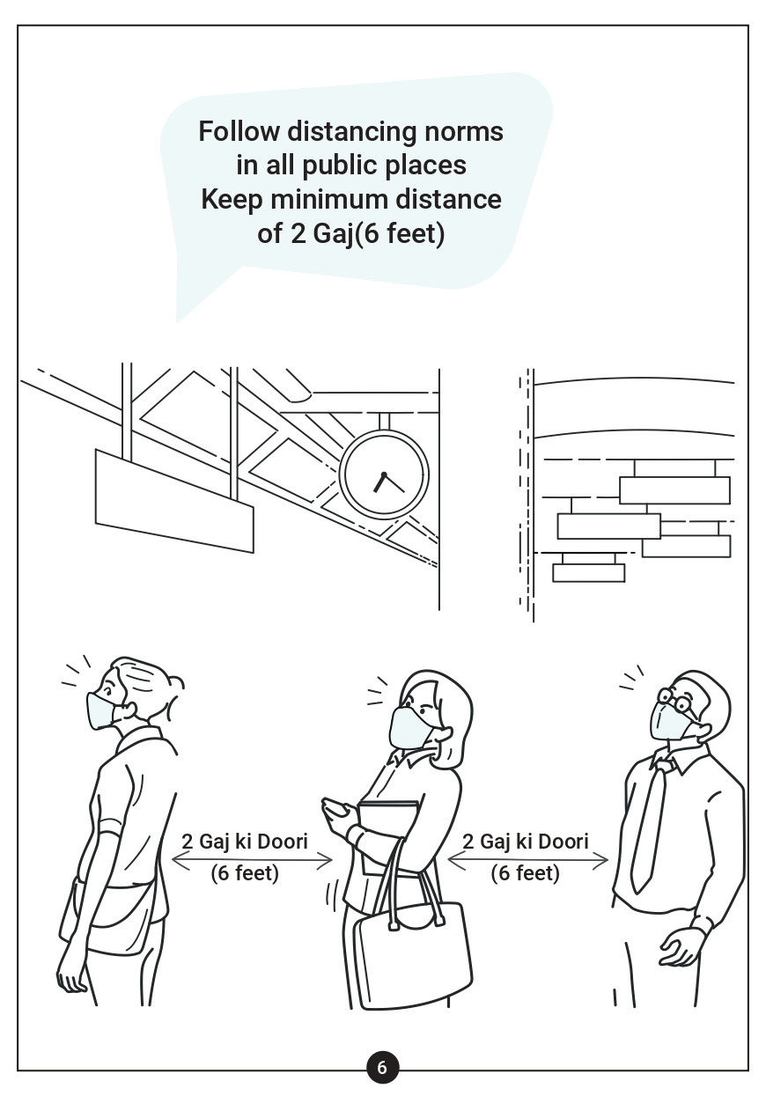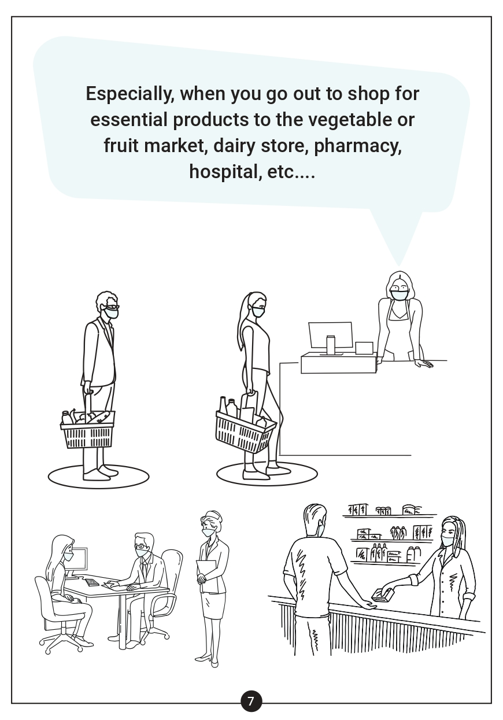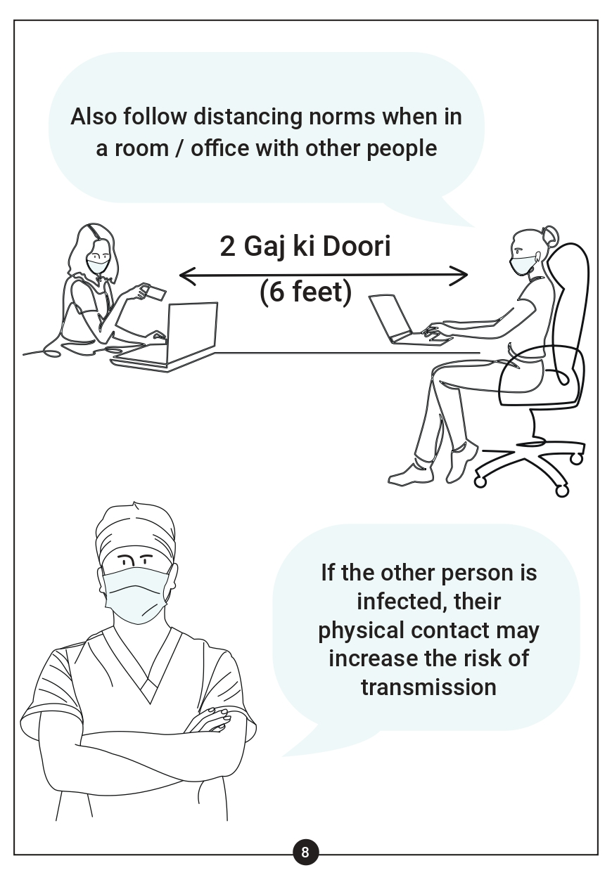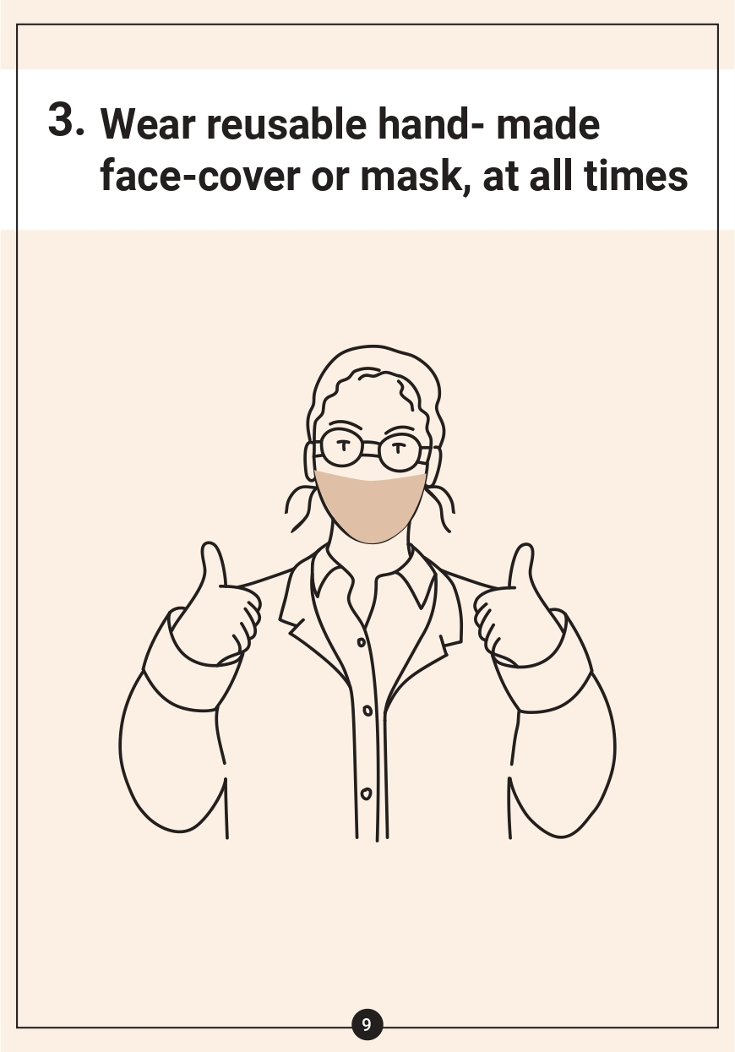

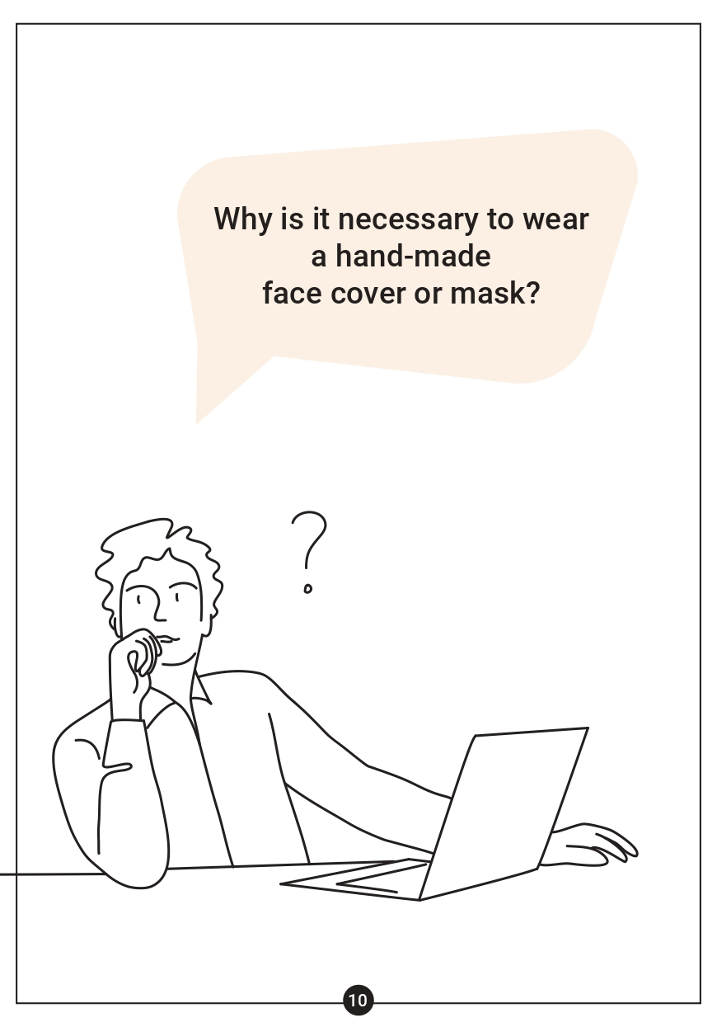

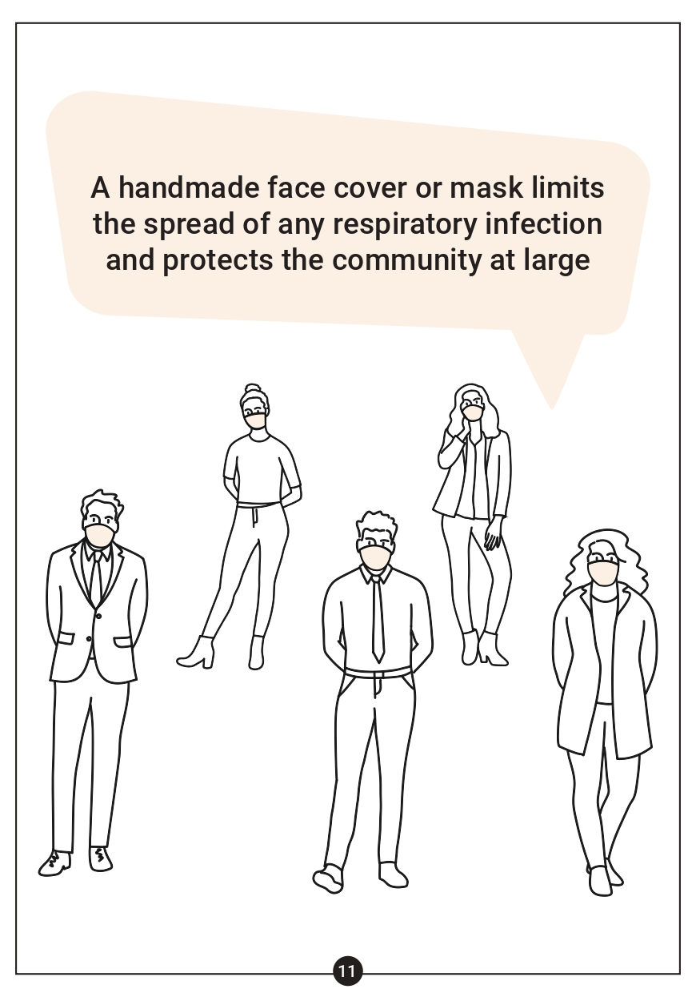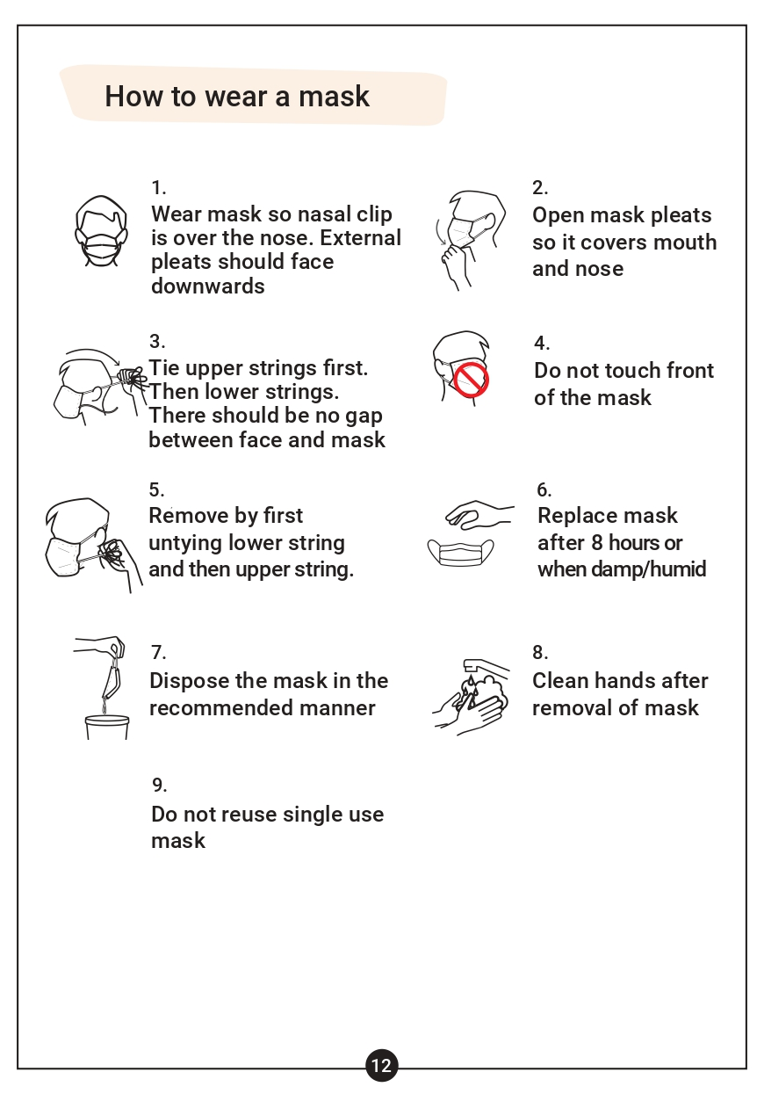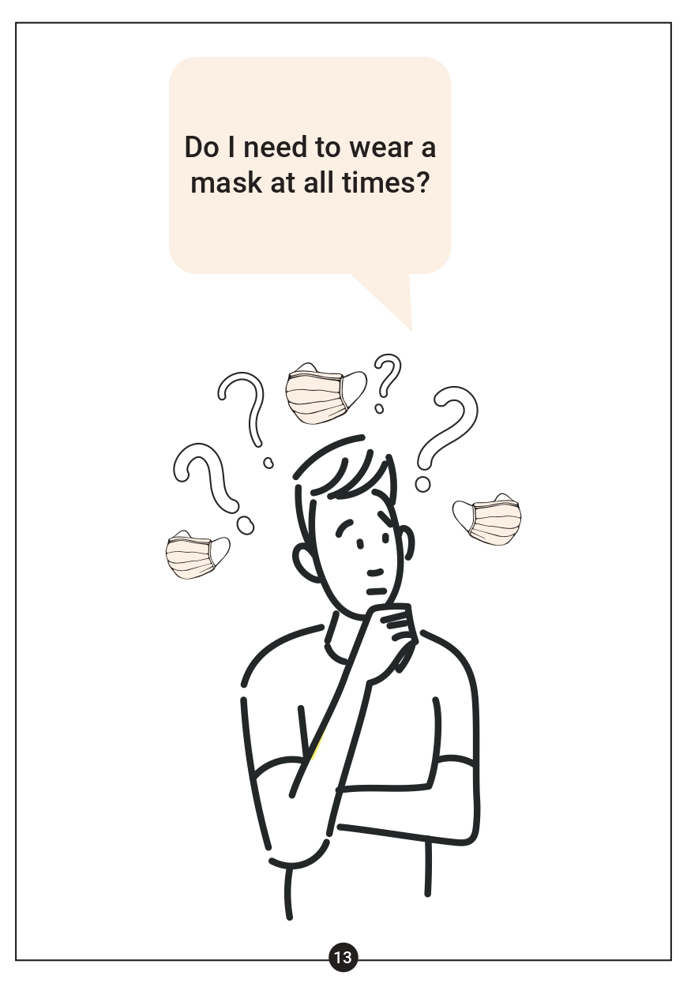

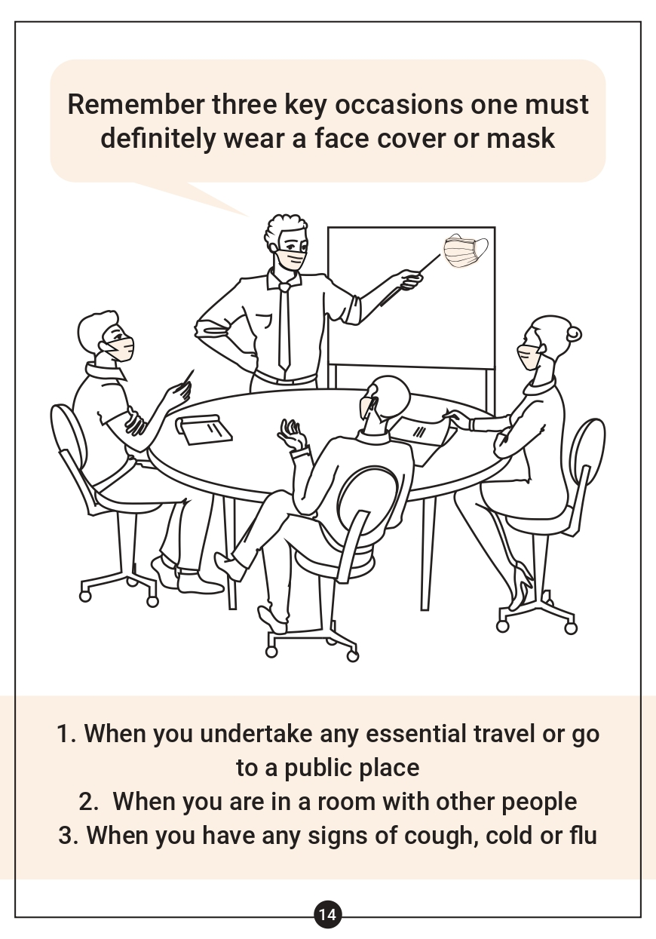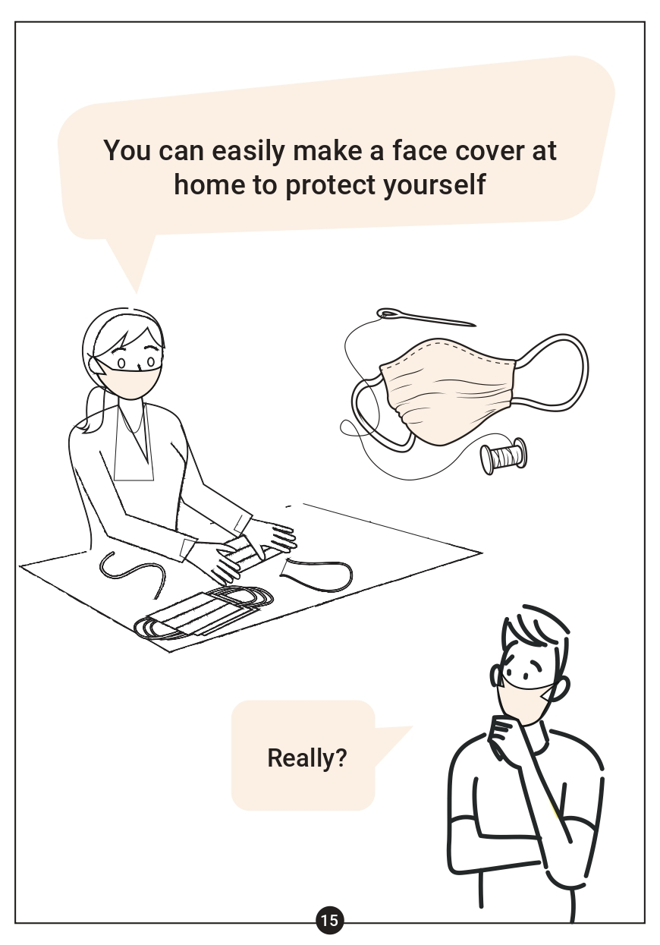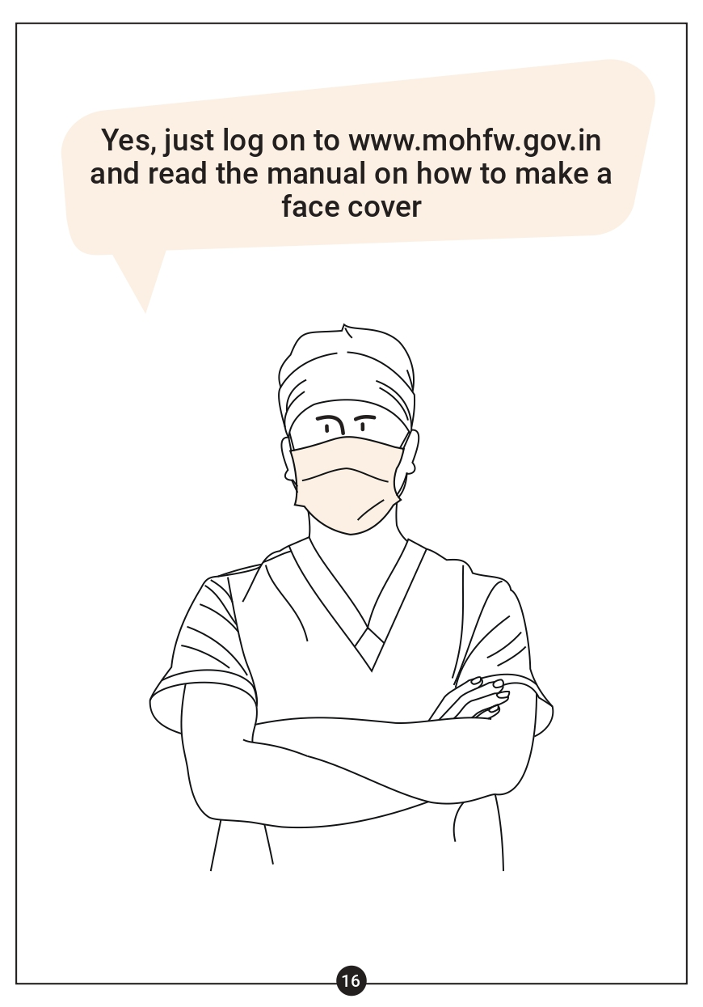

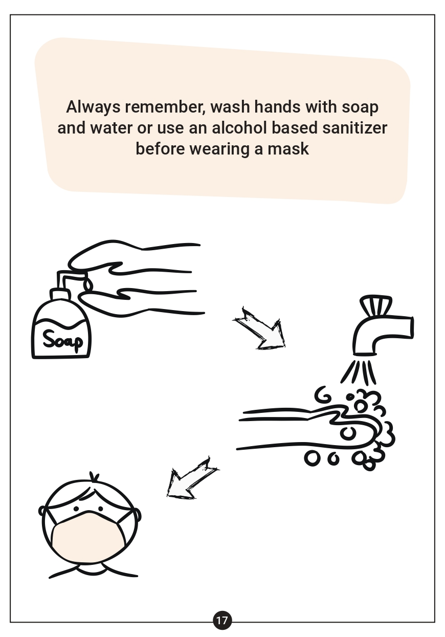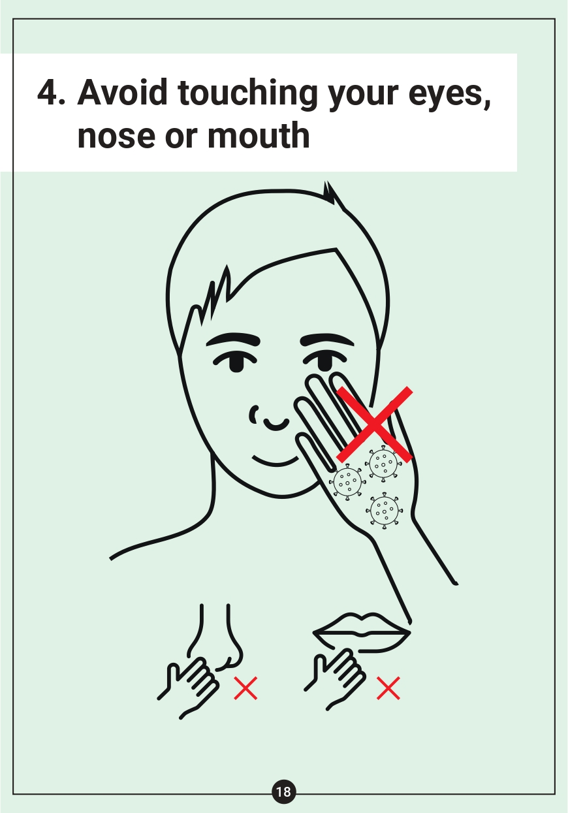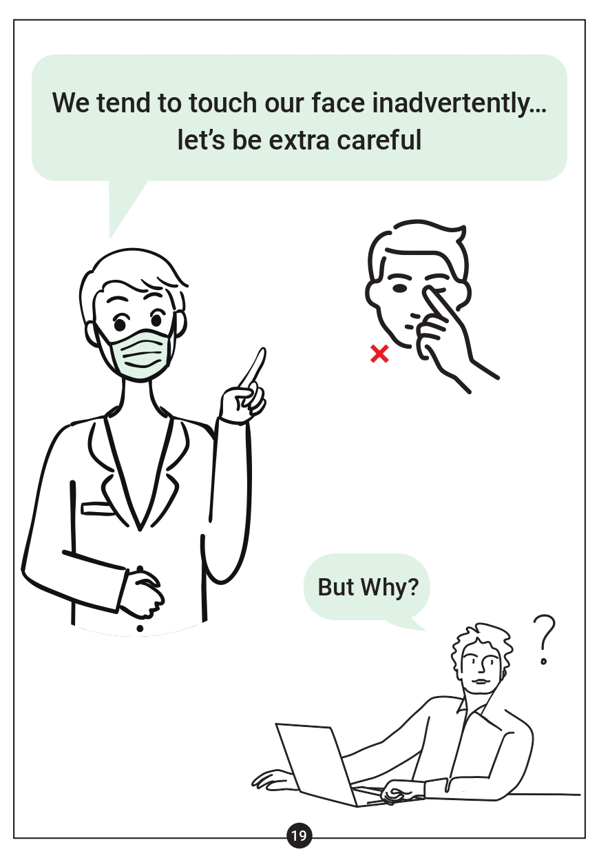

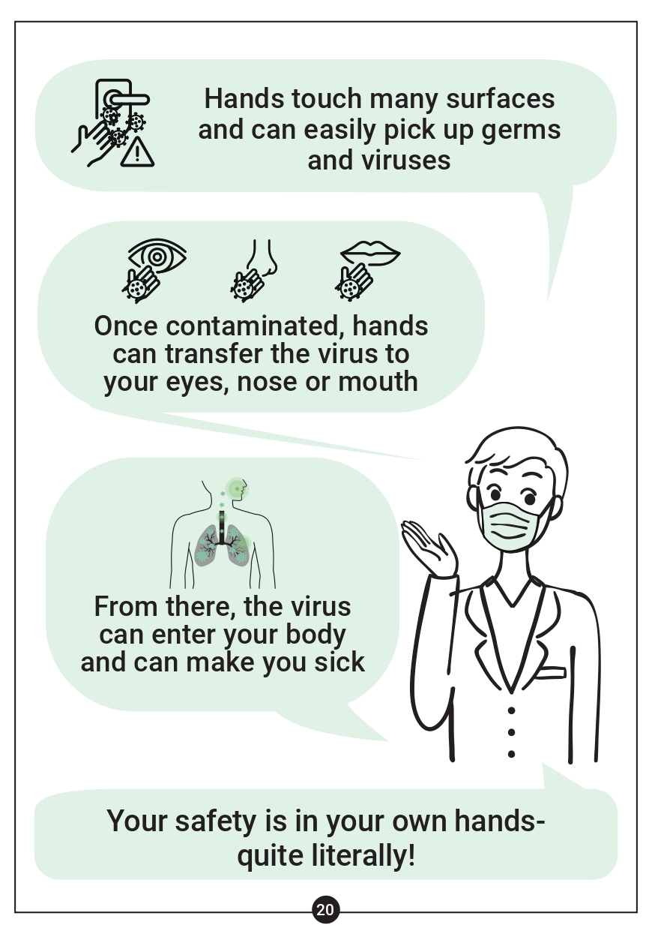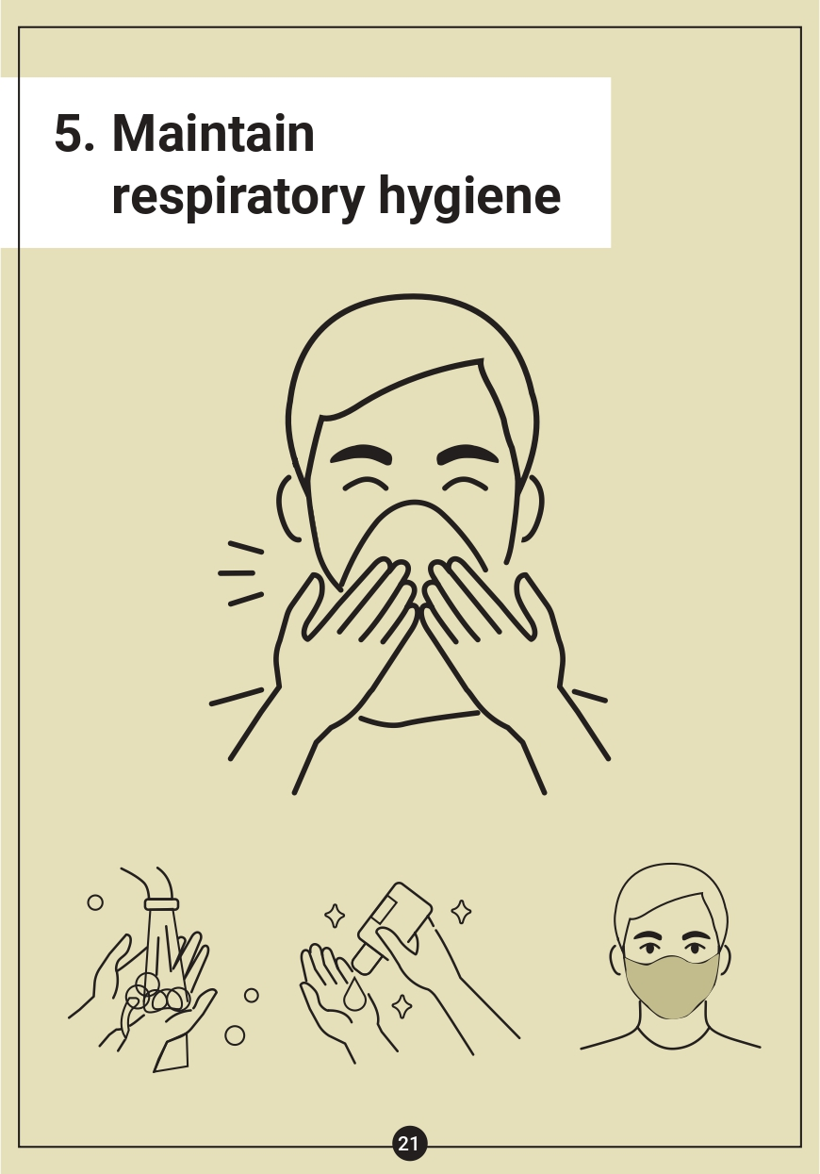

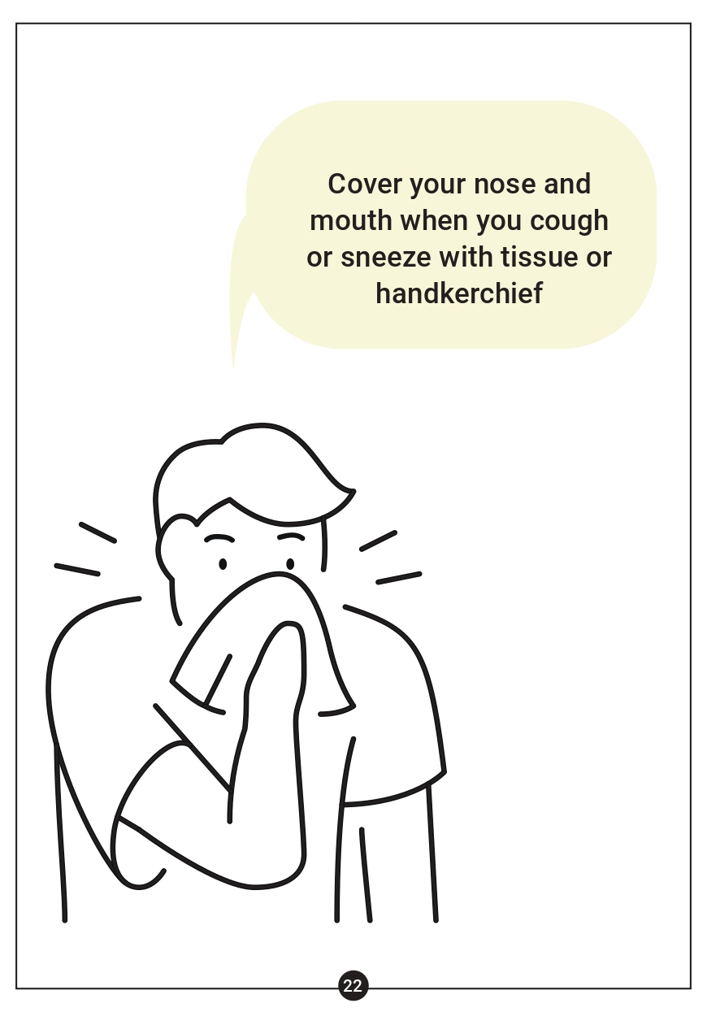

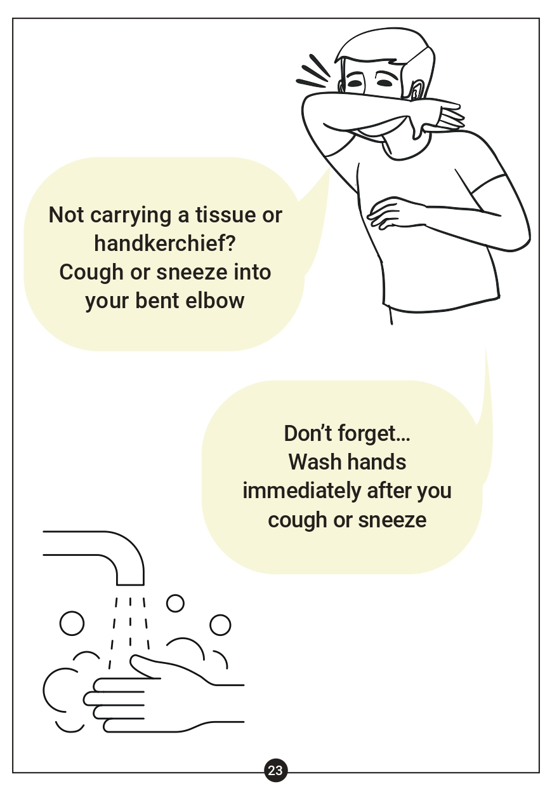

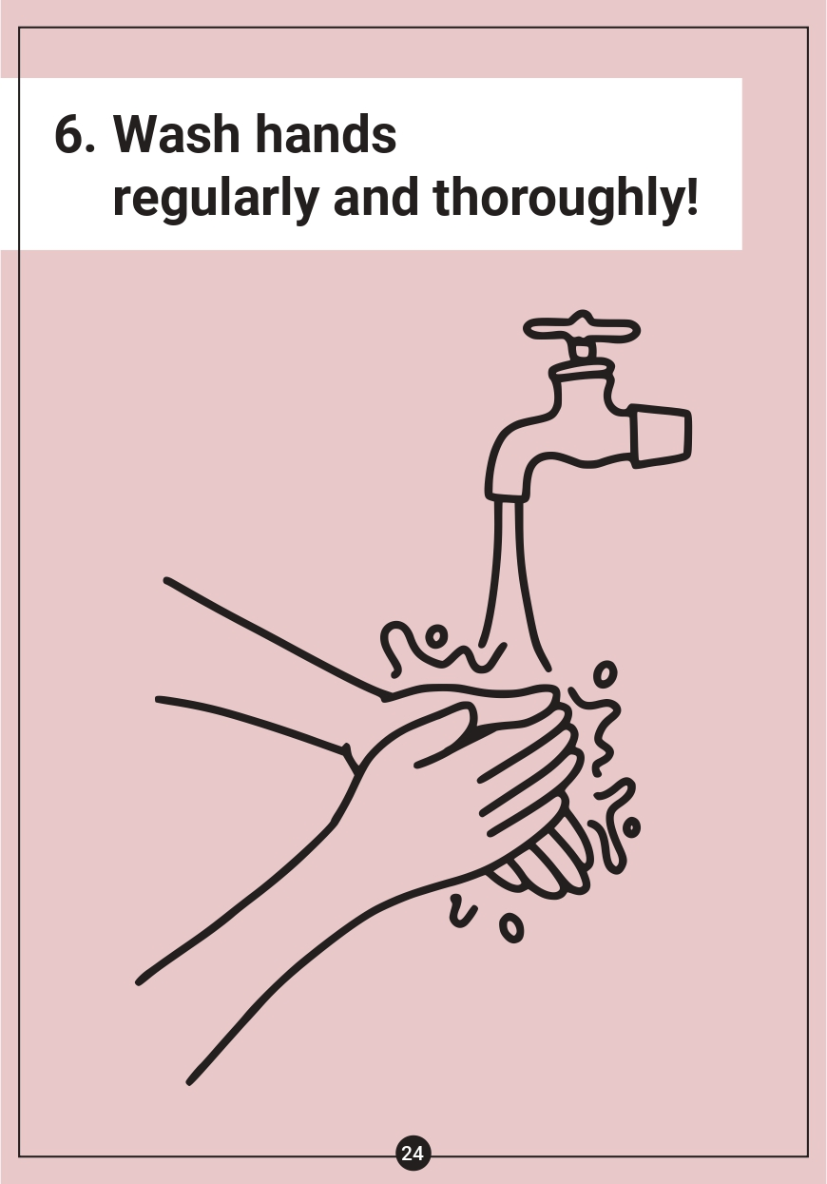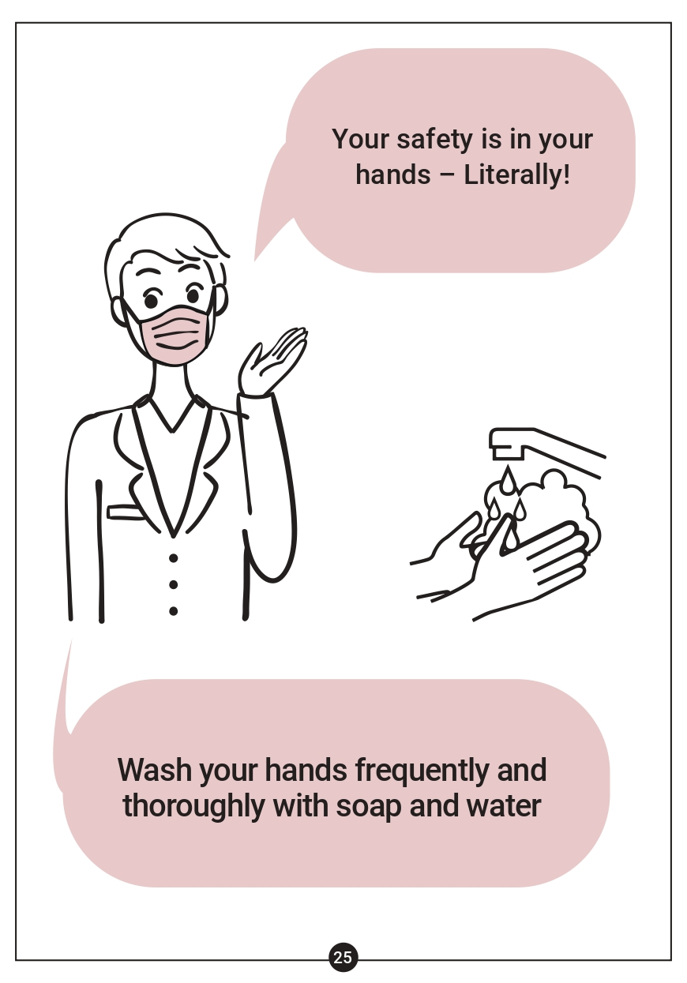

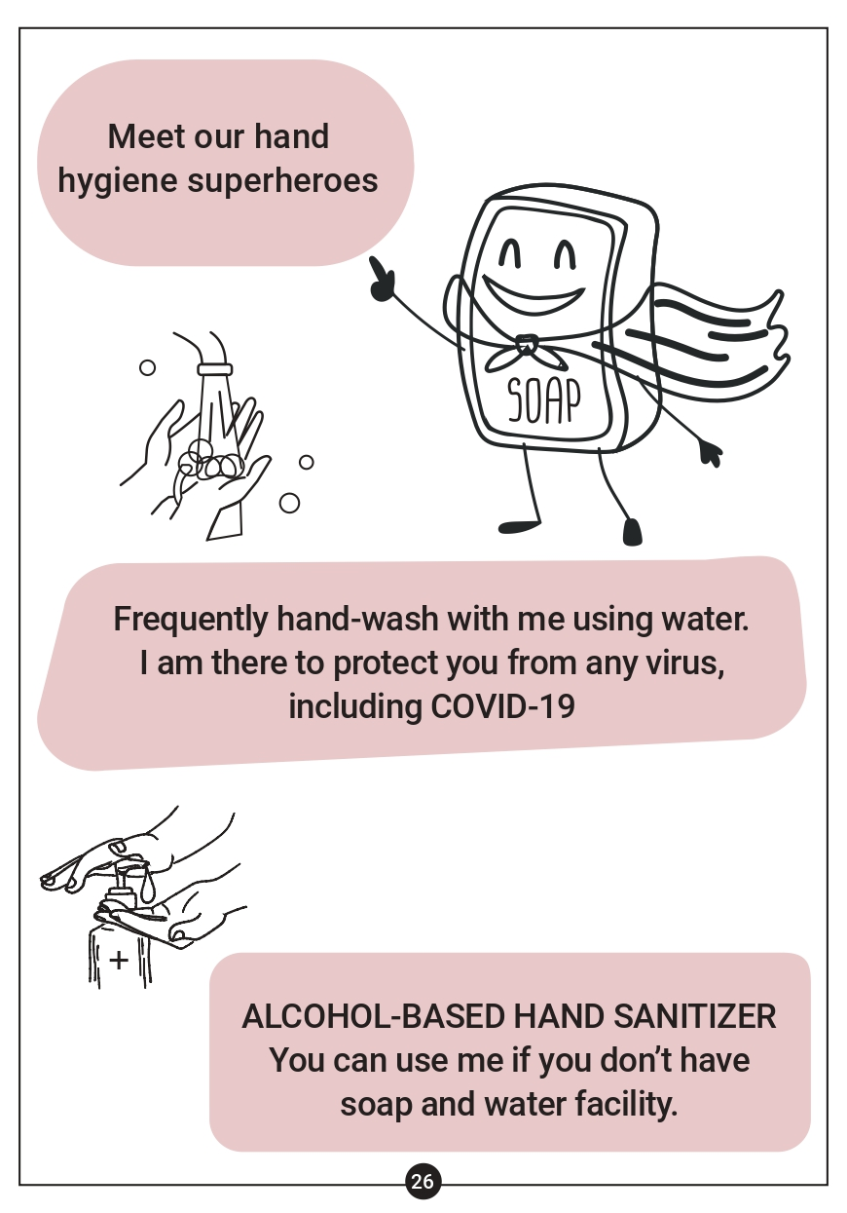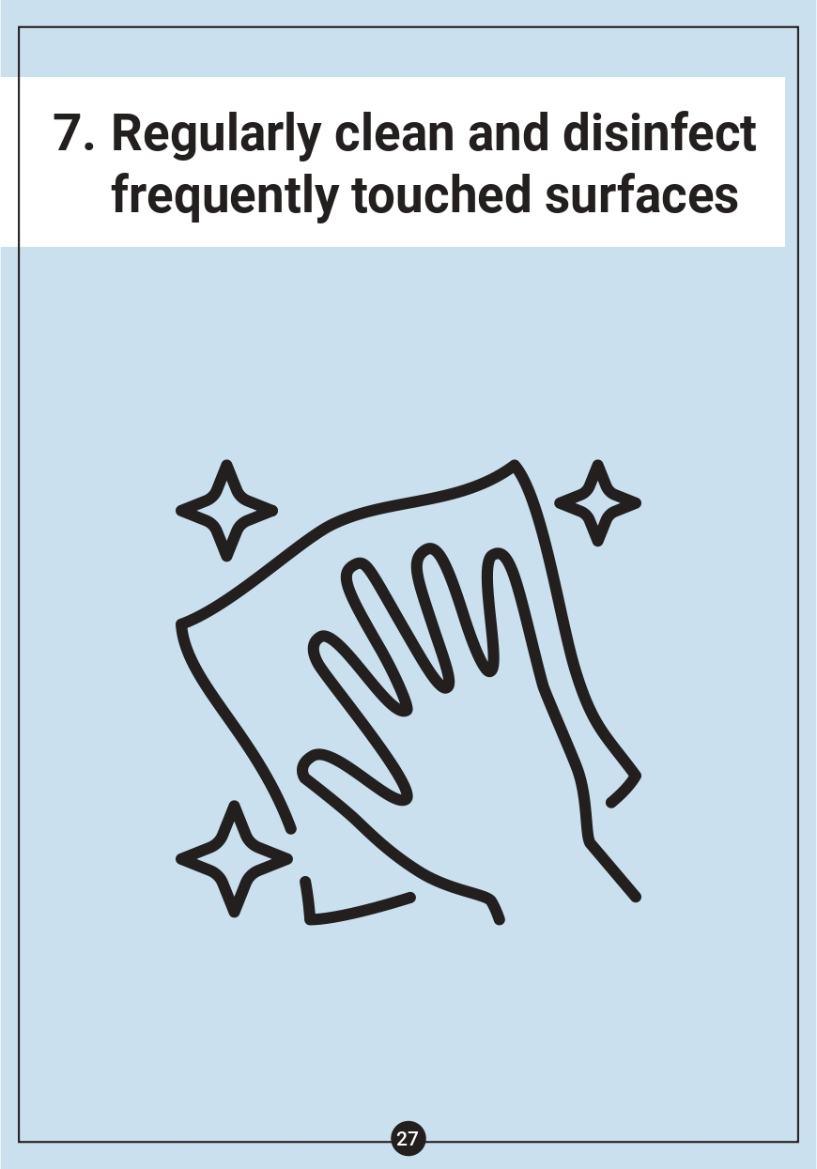

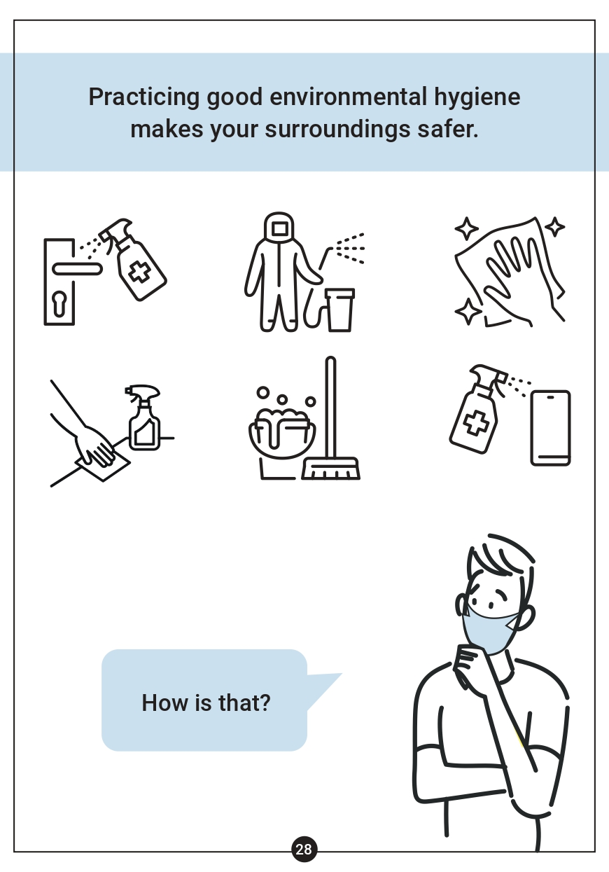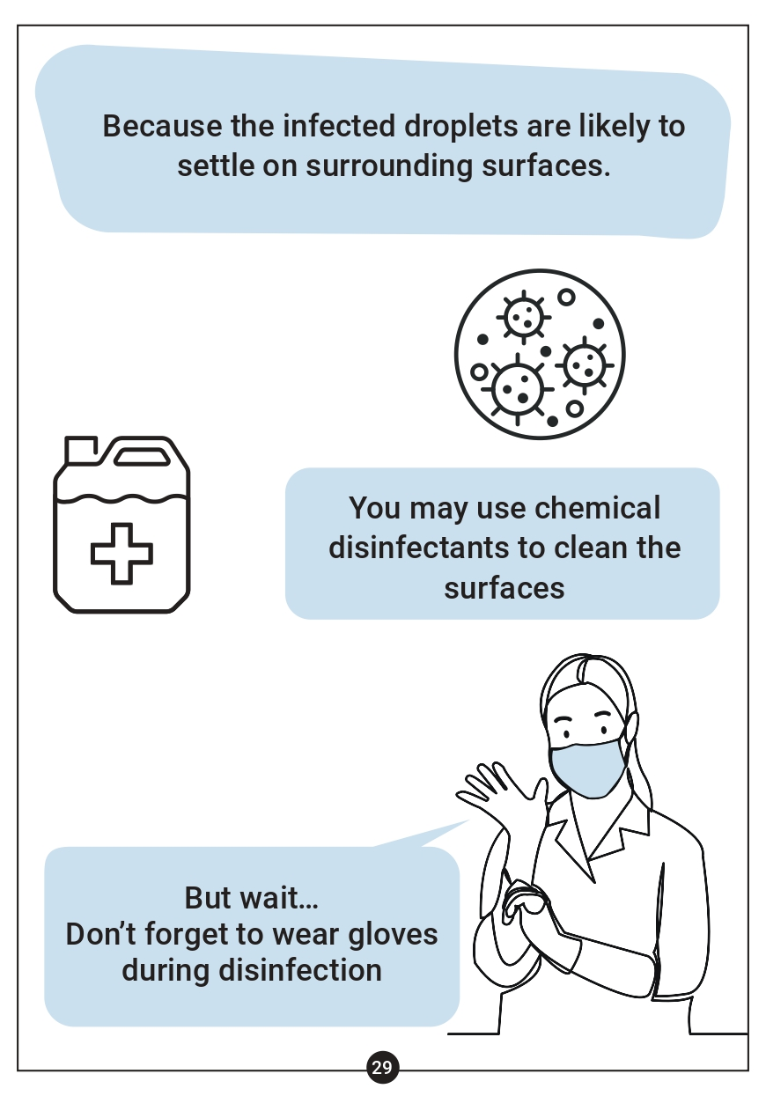

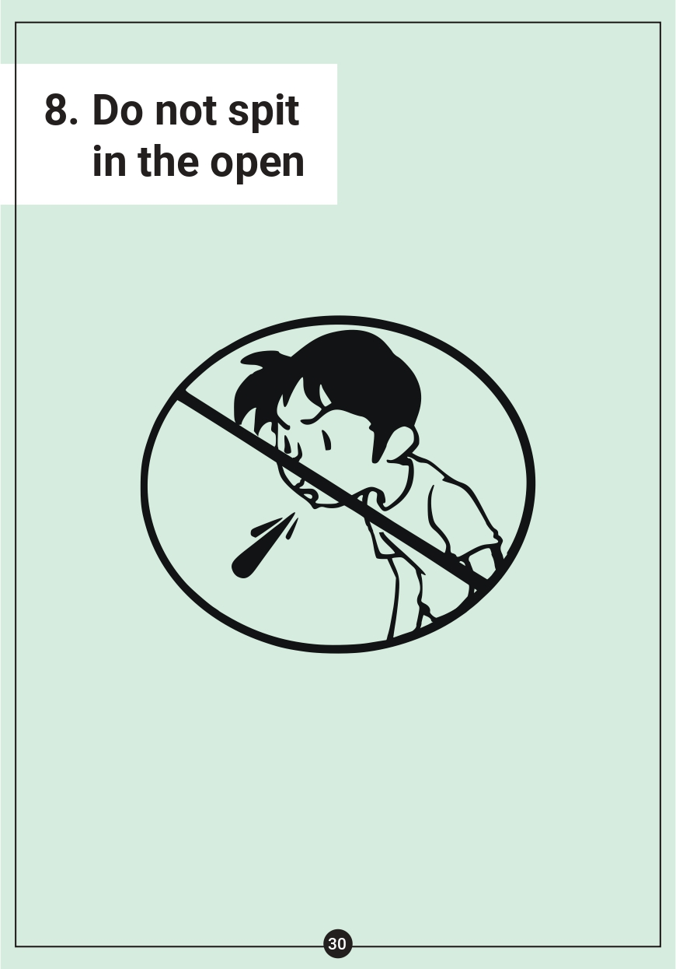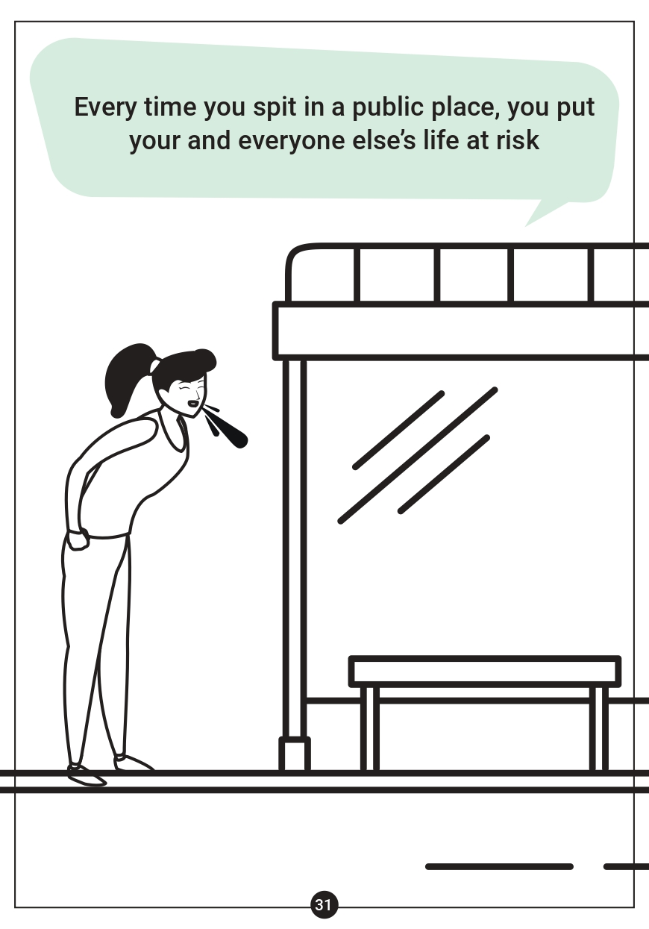

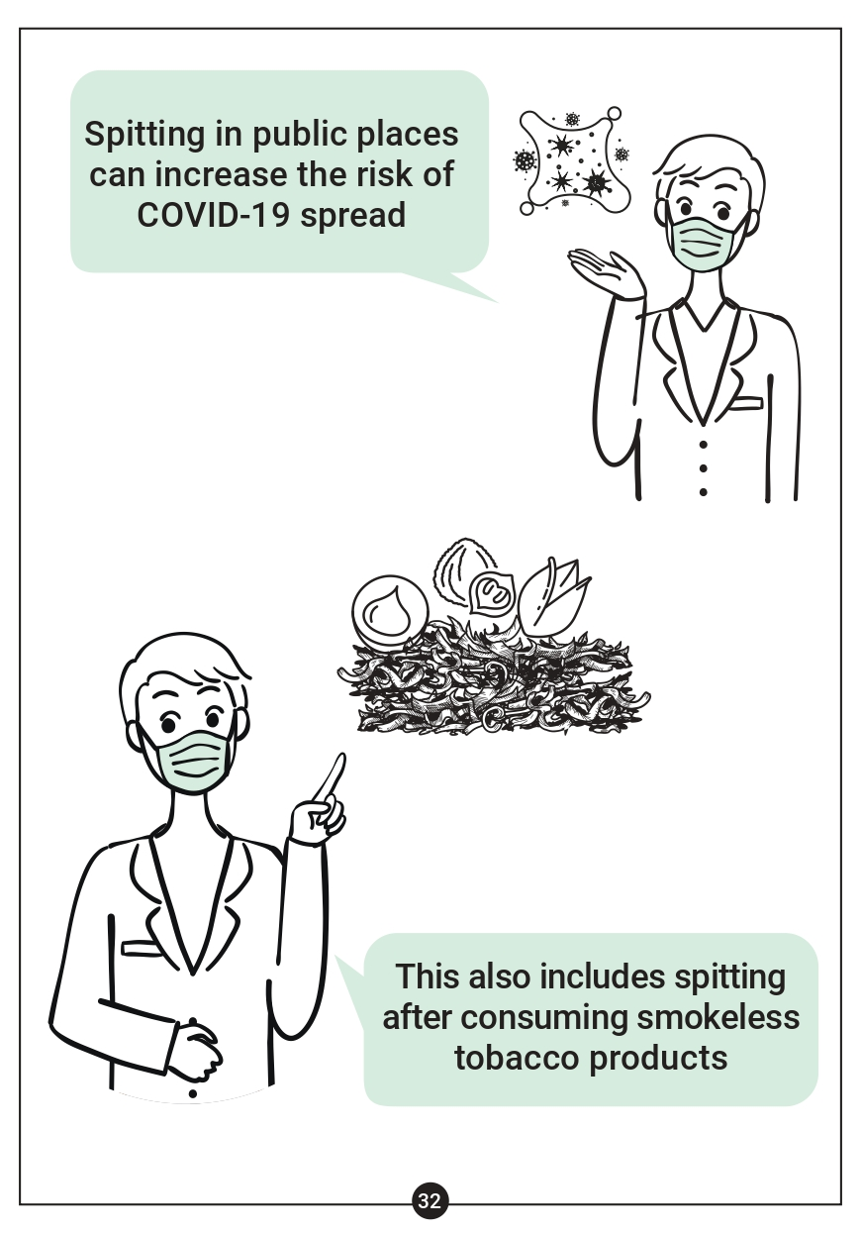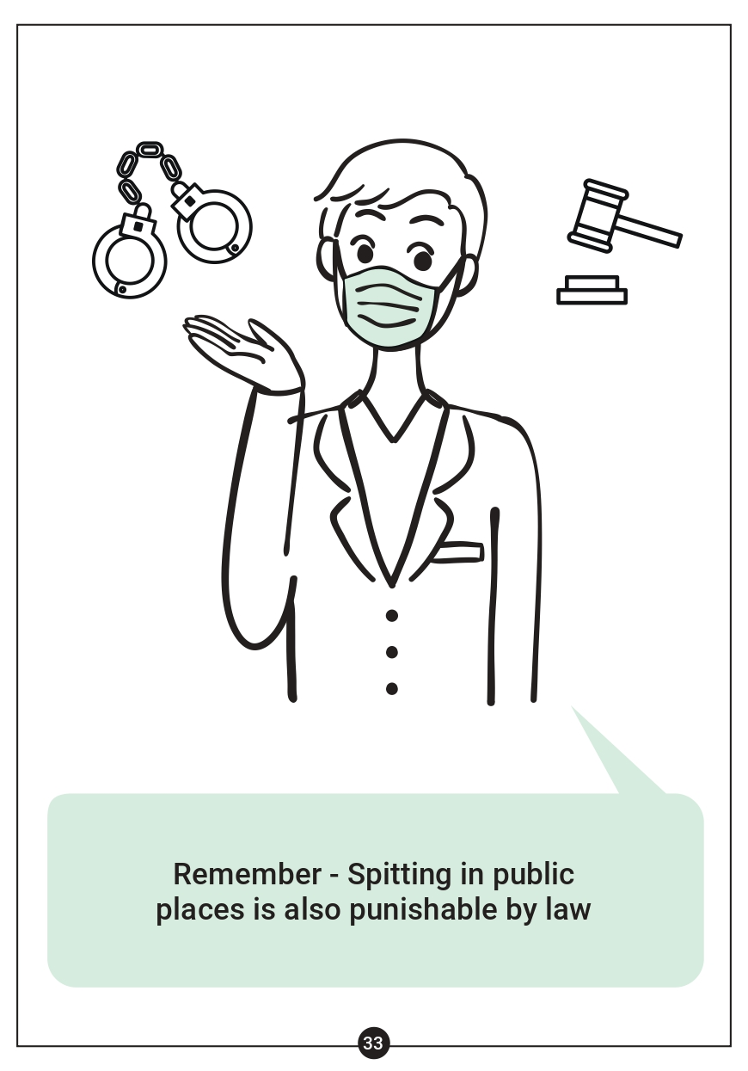

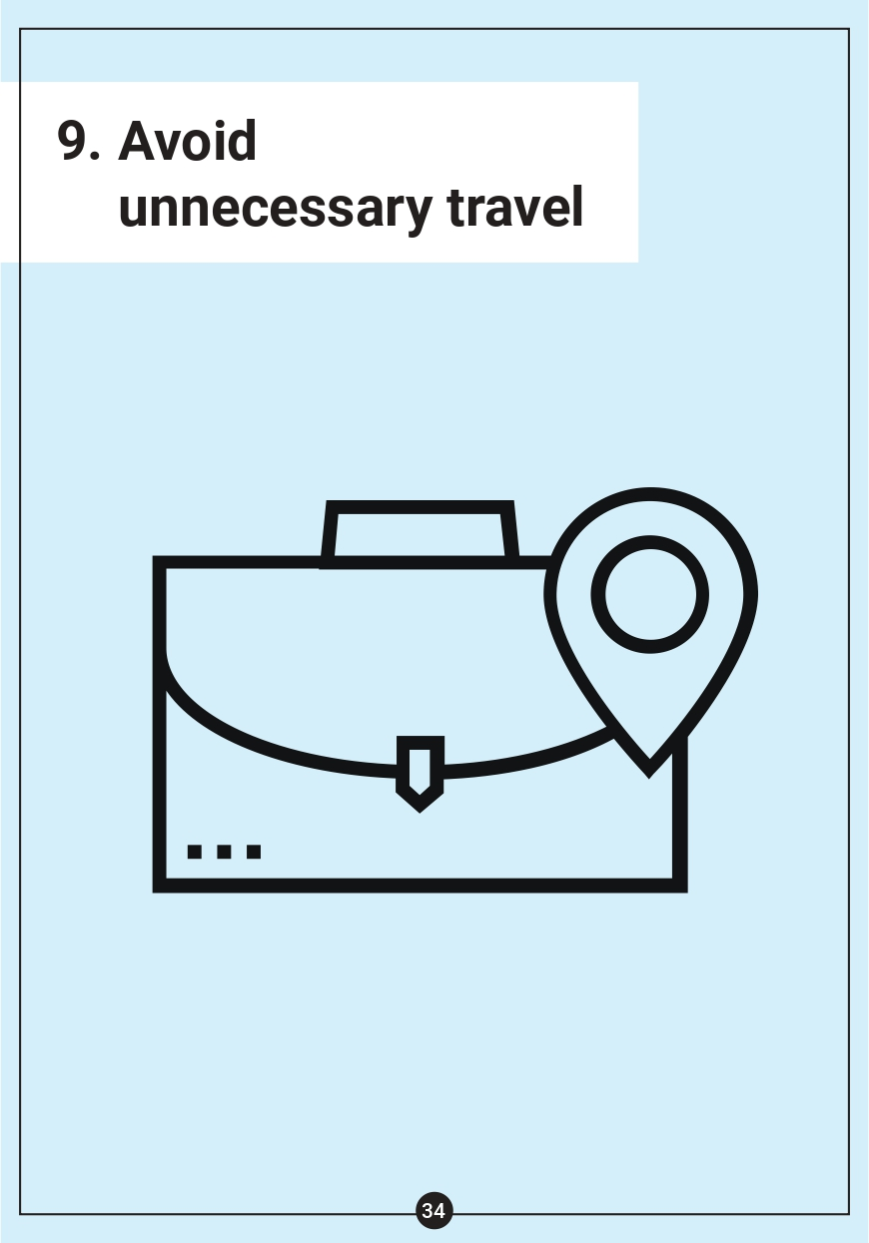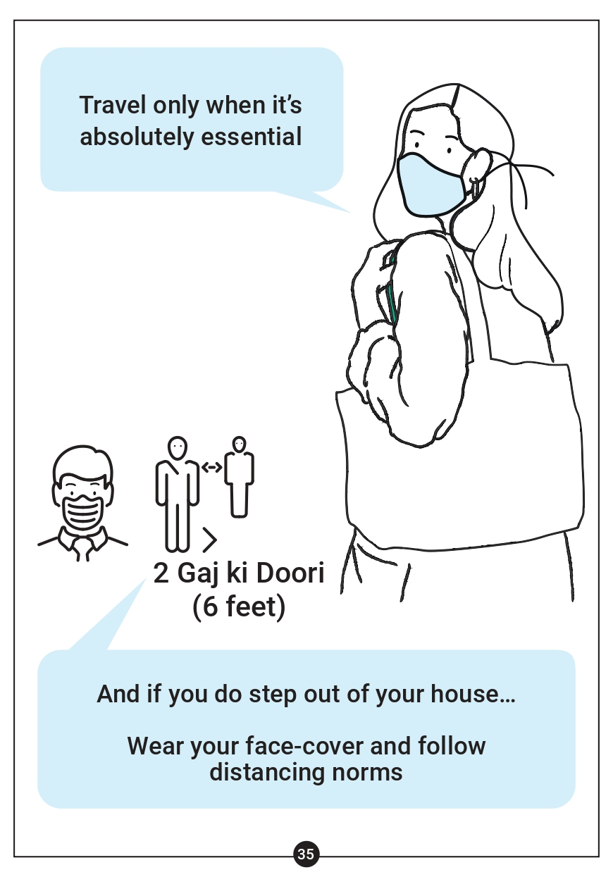

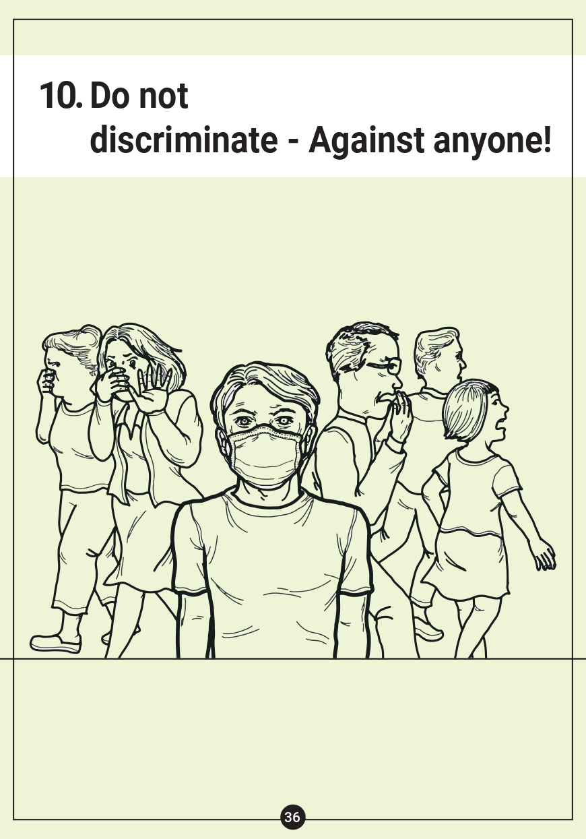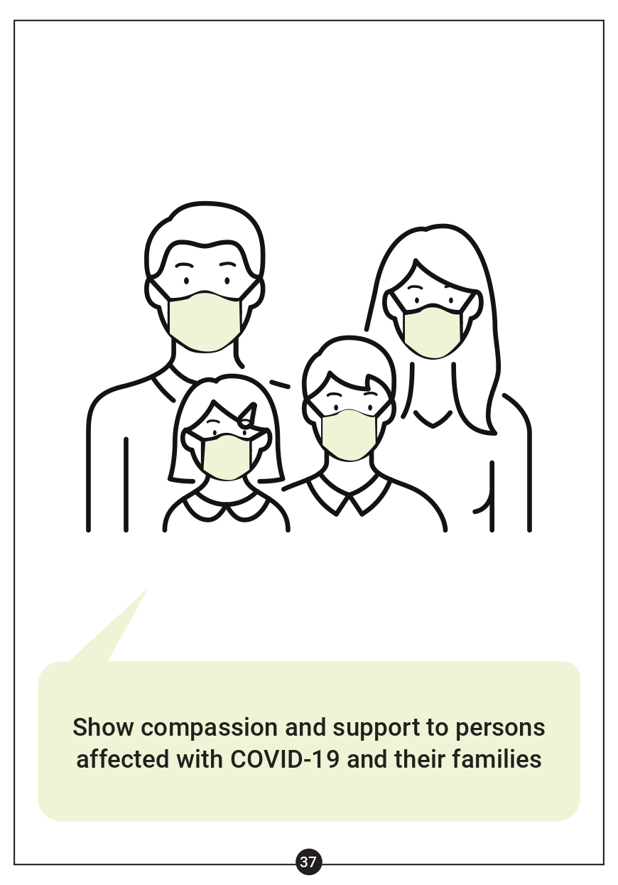

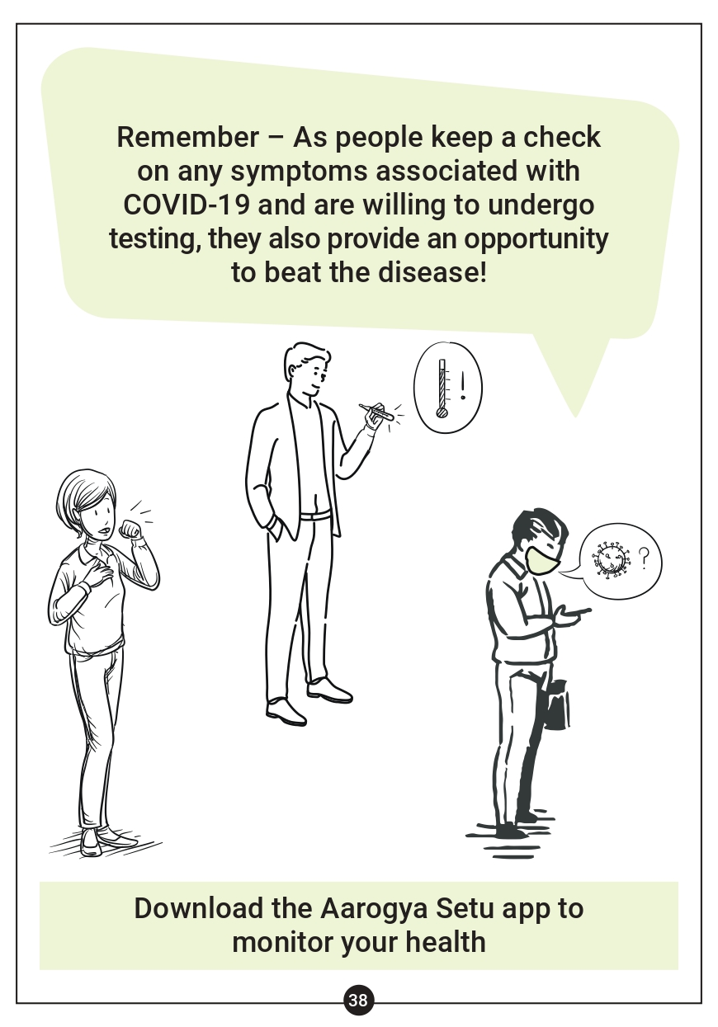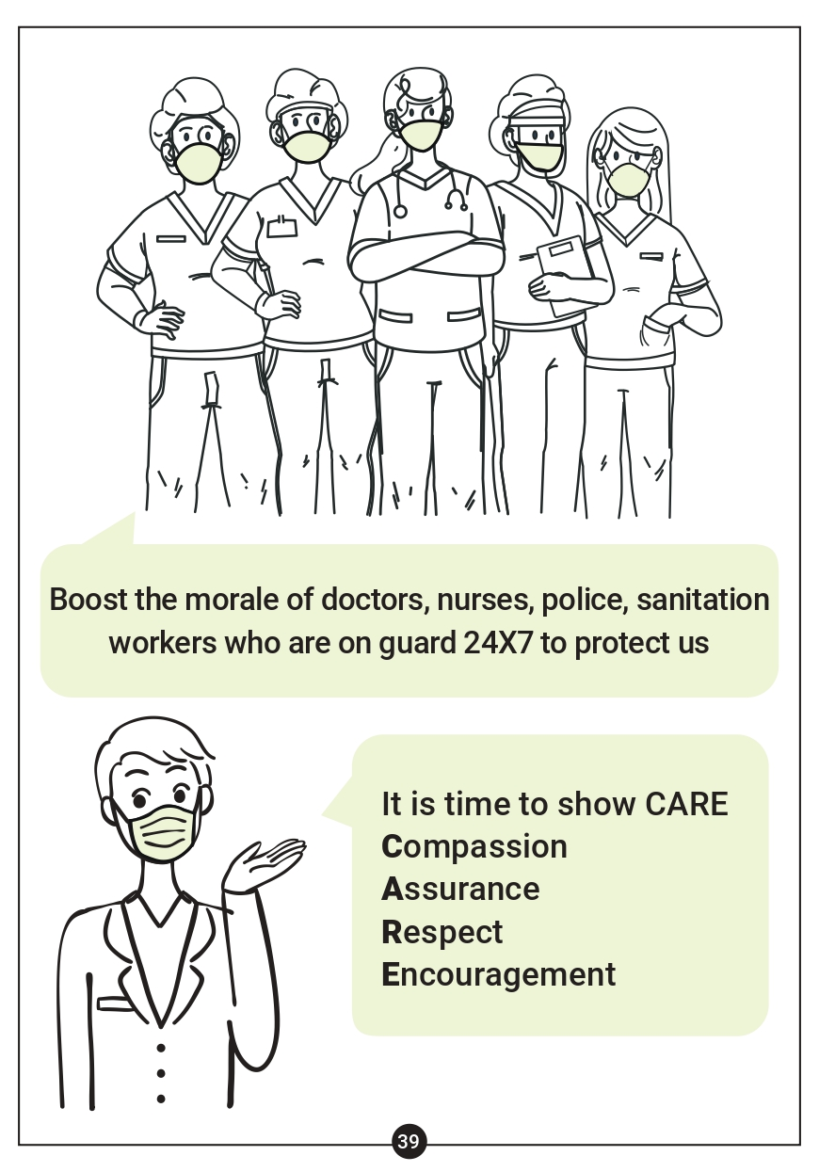

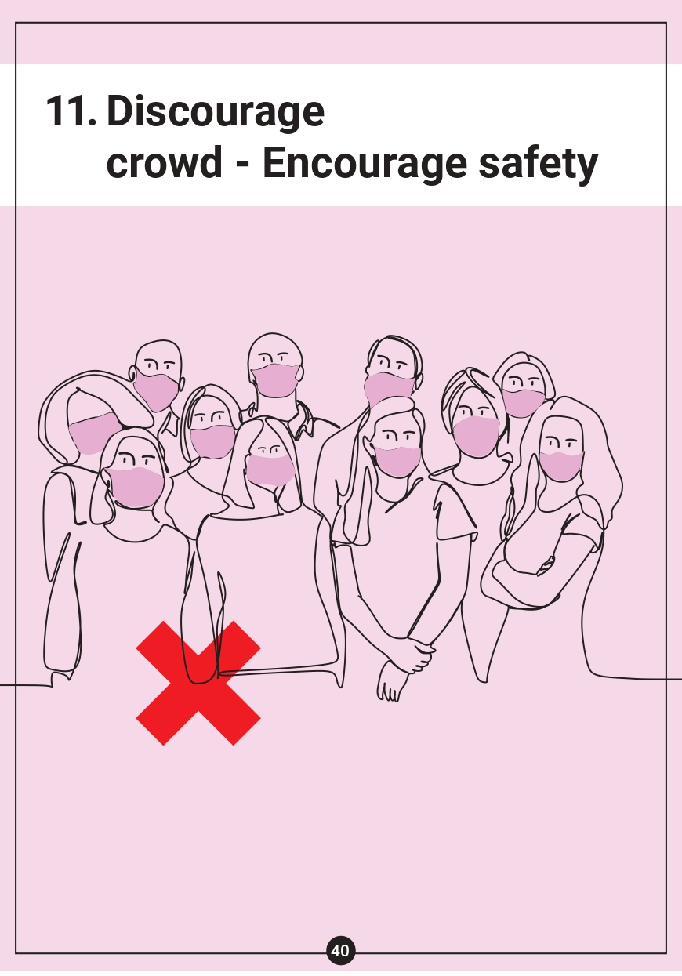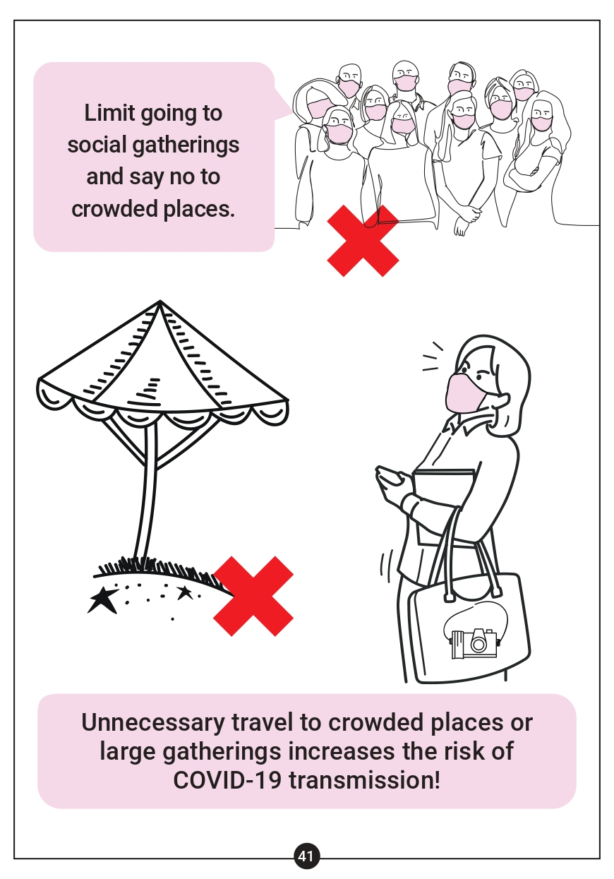

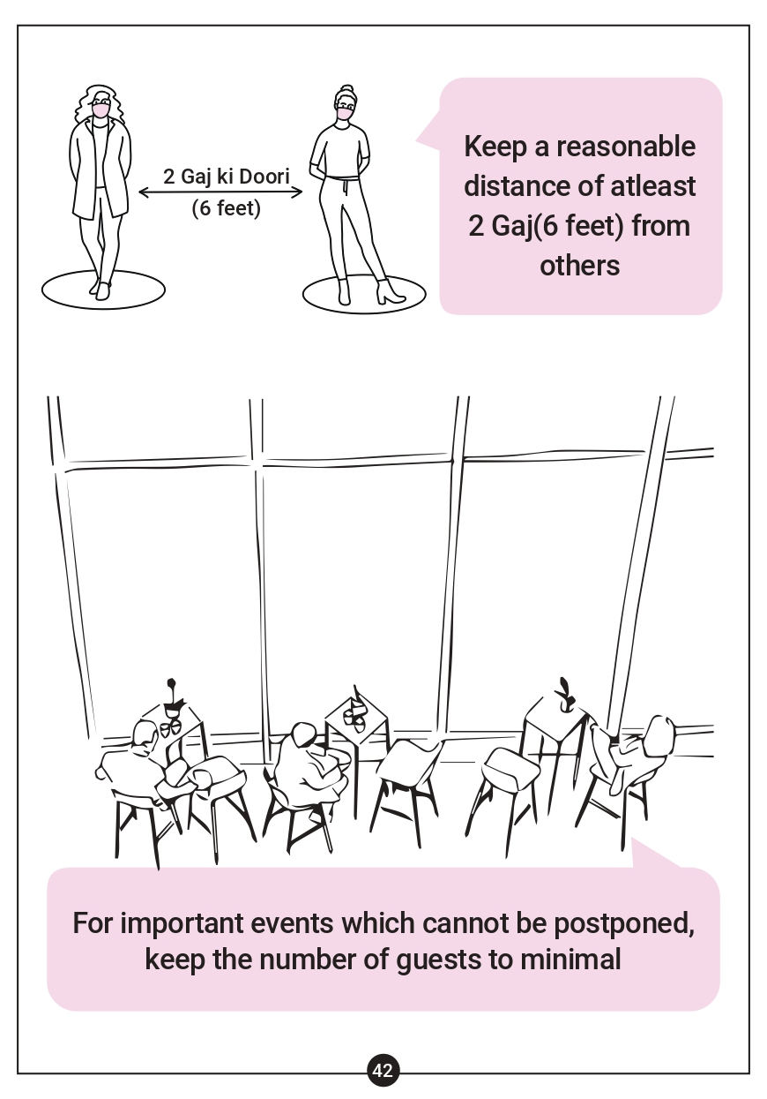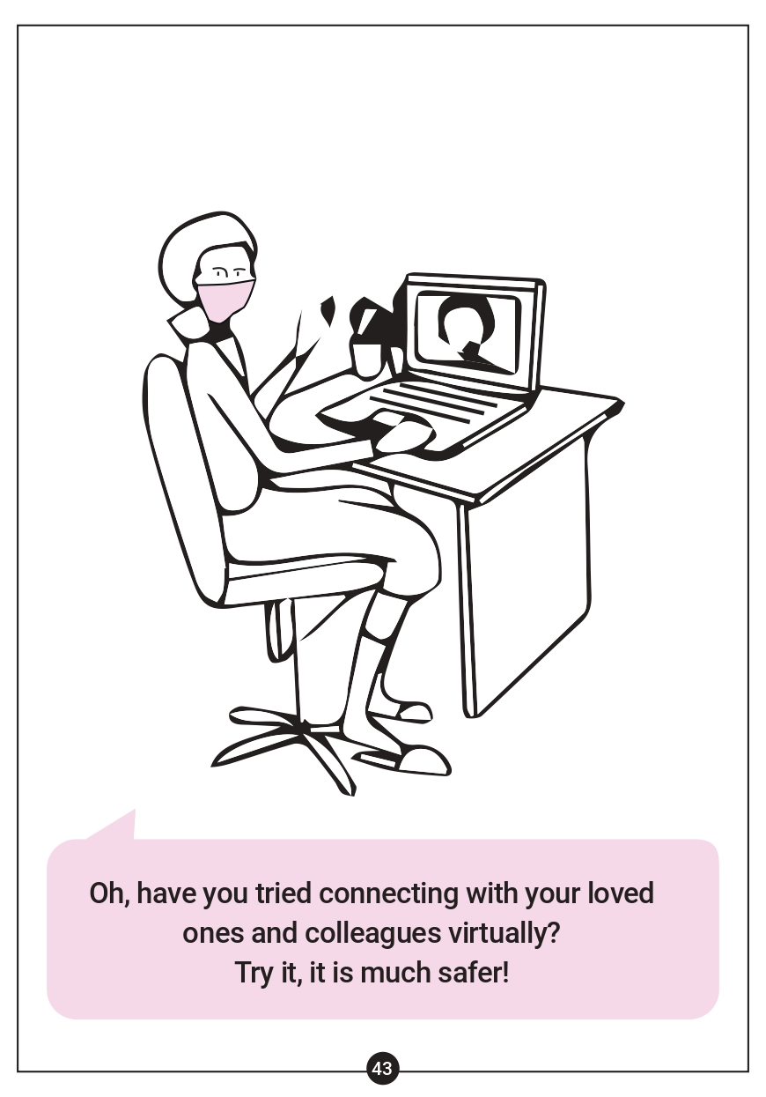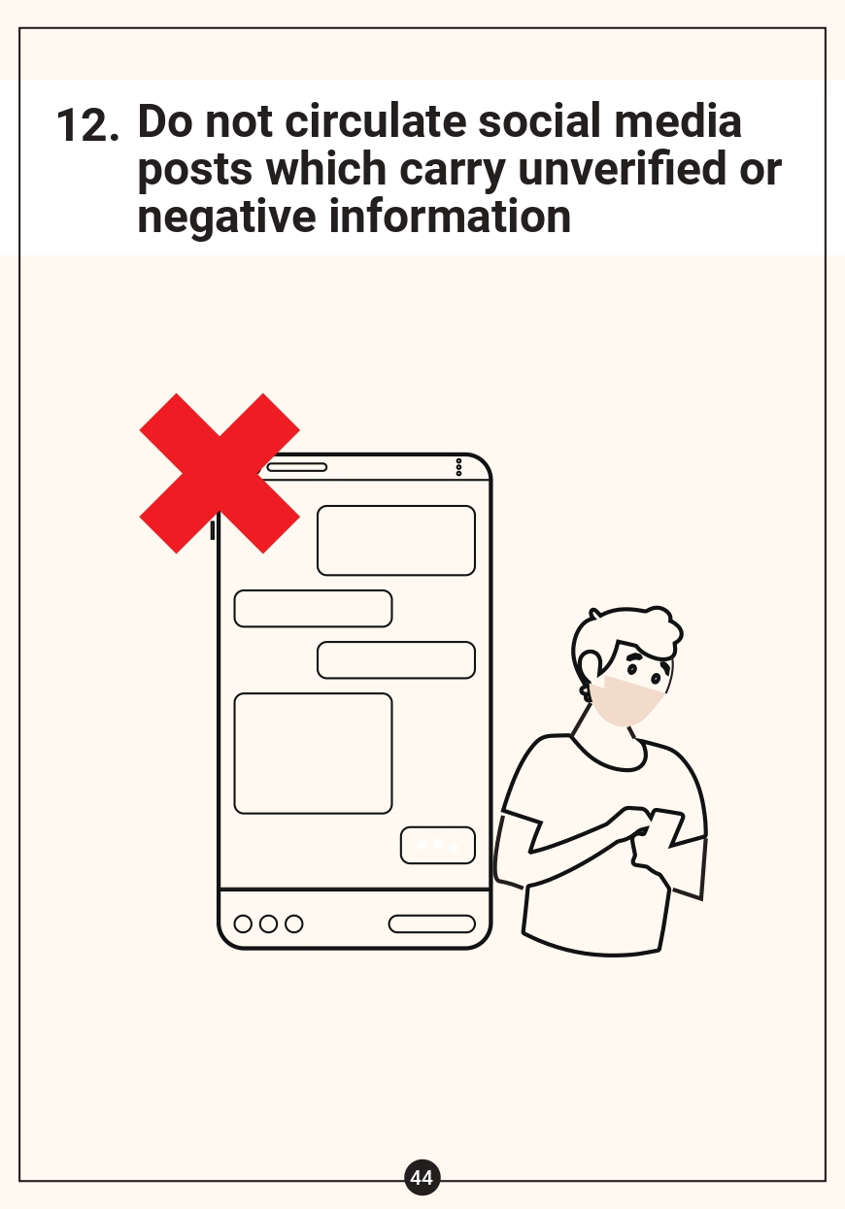

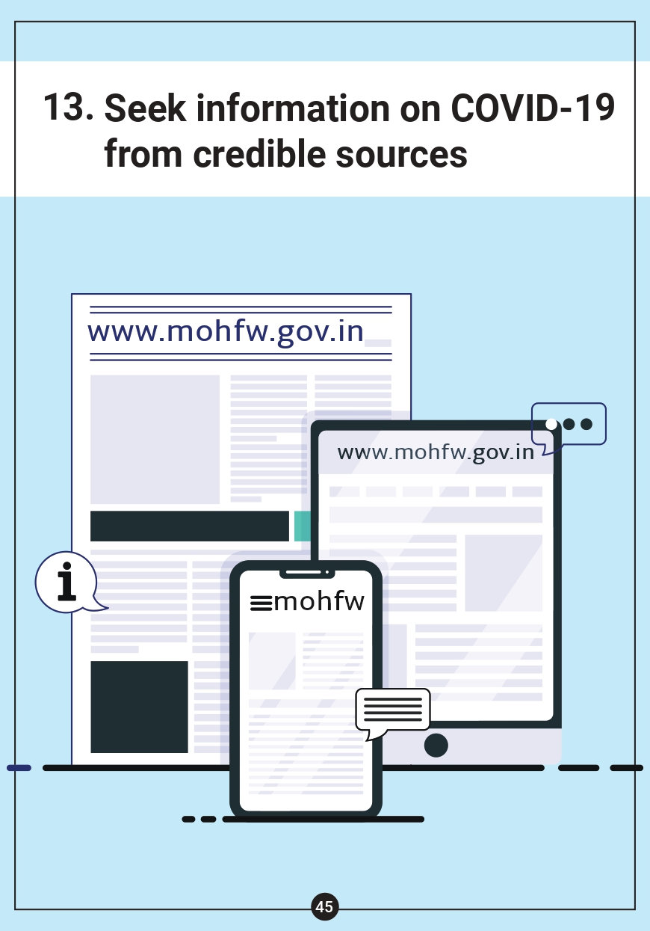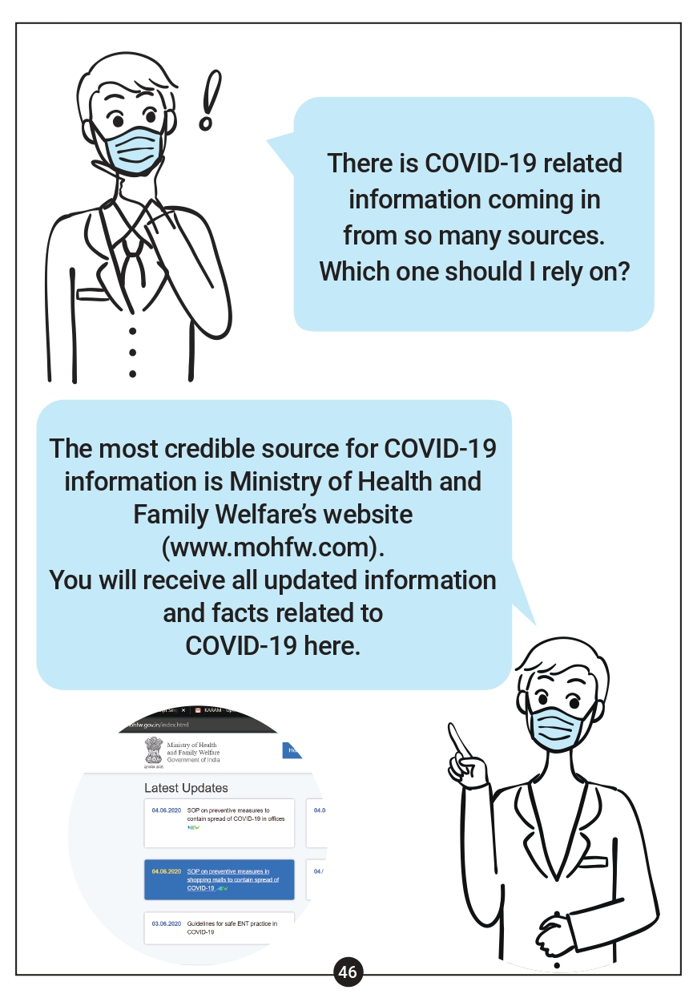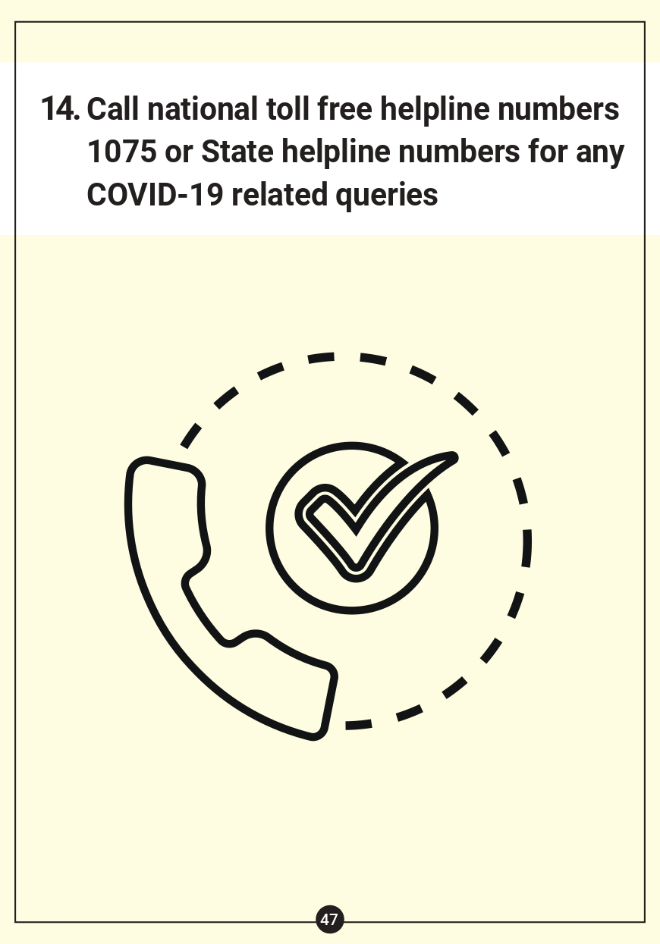

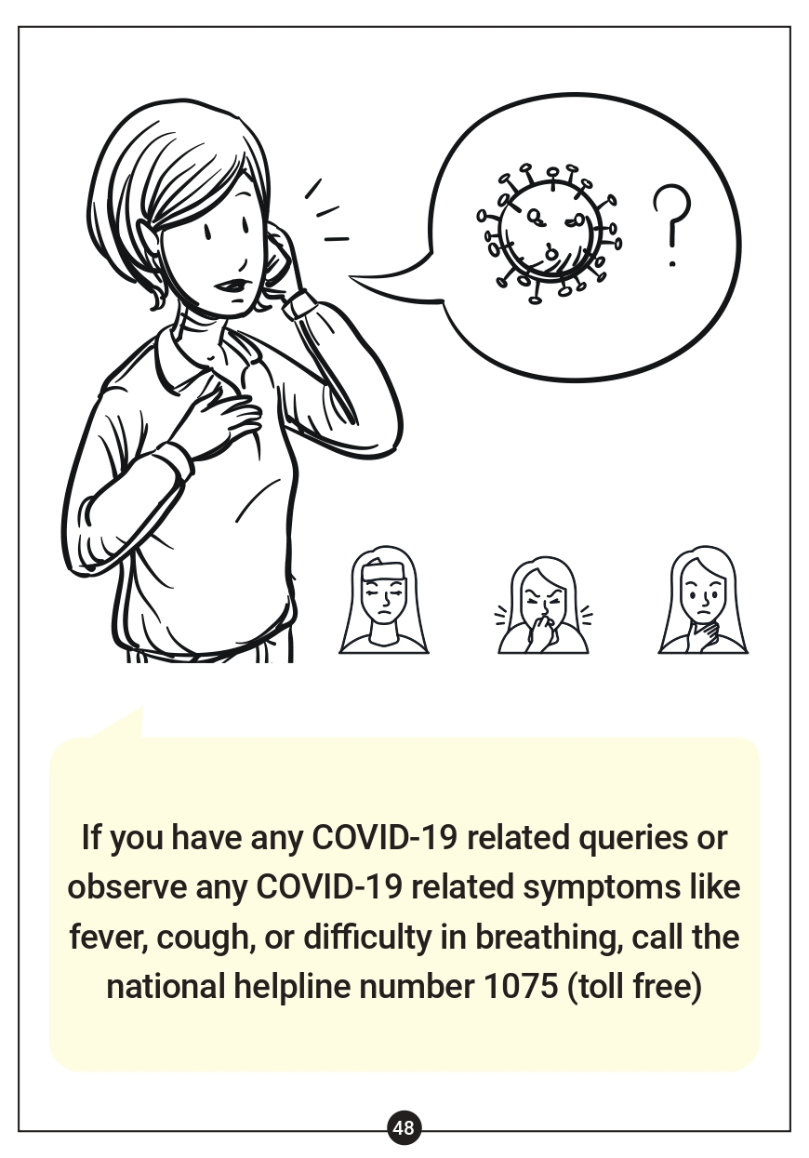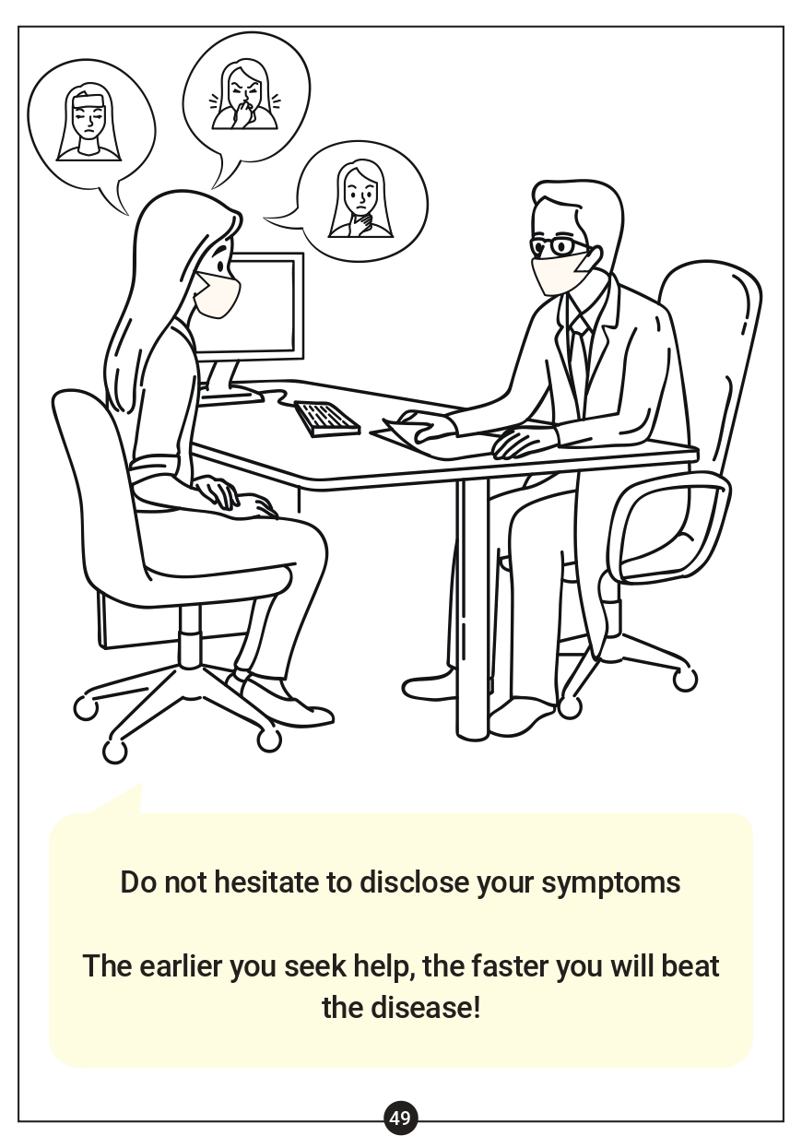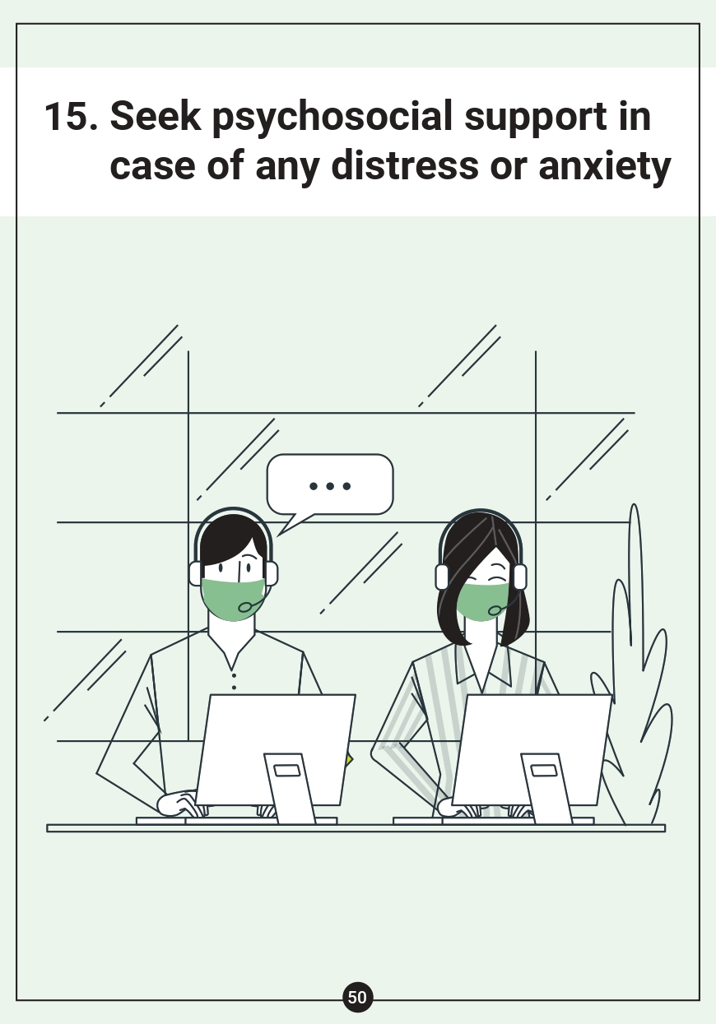

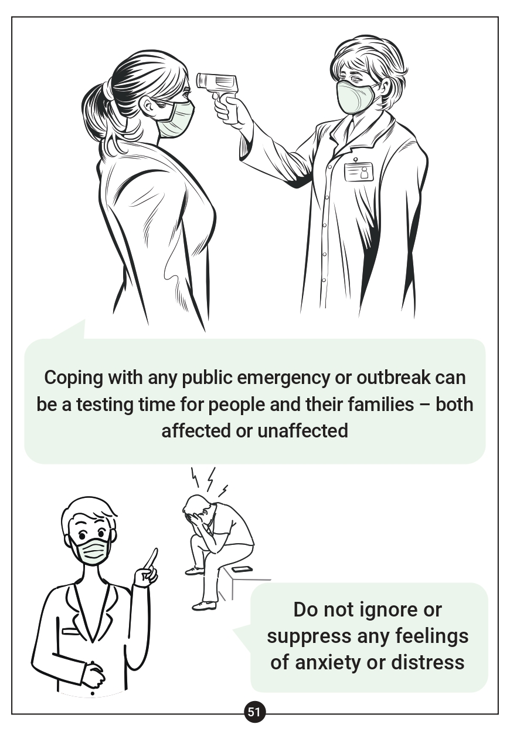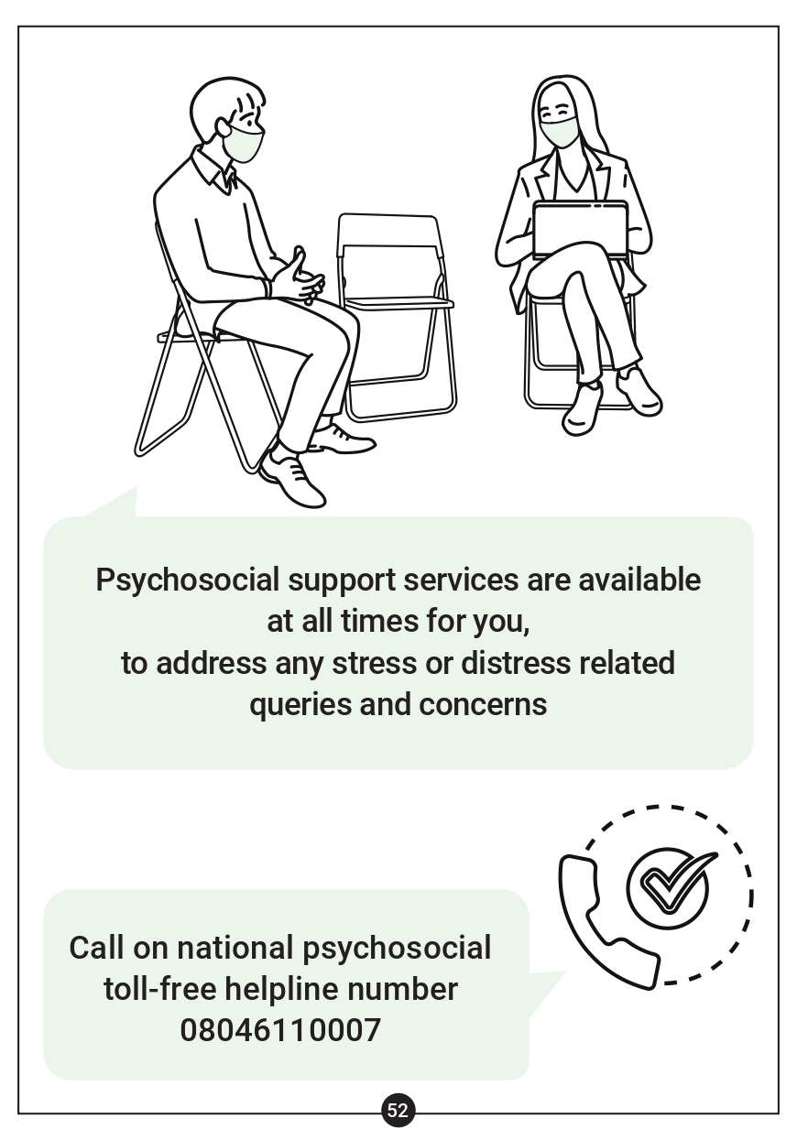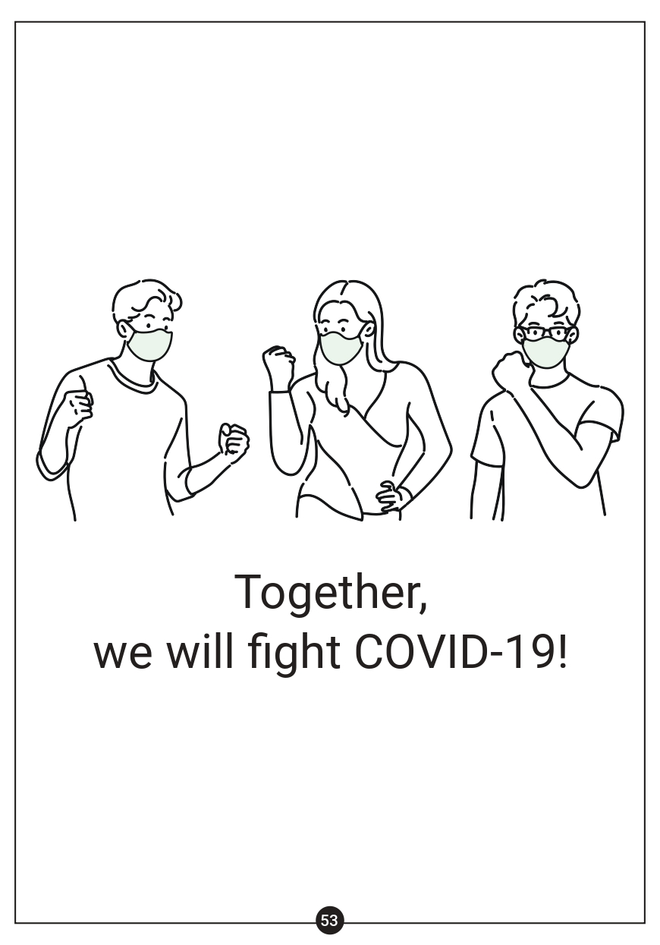

`THE END`

